

Subject Name: **Source Code Management**

Subject Code: **CS181**

Cluster: **BETA**

Department: **CSE**



|  |  |  |
| --- | --- | --- |
| **Submitted By:**  **Archit Vohra**  2110990249  **G-08/B**  **TASK 1.1** |  | **Submitted To:**  **Mr. Monit Kapoor** |

**Experiment 1:**

**Aim:** Setting up of Git Client

**Theory:**

GIT –> It is basically used for pushing and pulling of code. We can use git and git-hub parallel to work with multiple members or individually. We can make , edit , recreate ,copy or download any code on git hub using git.

What is GIT ? –> It’s a Version Control System(VCS) -> It is a software or we can say a server by which we are able to track all the previous changes in the code.

Advantages of GIT –>

**Procedure:** We can install Git on Windows, using the most official build which is available for download on the GIT’s official website or by just typing ( s c m git ) on any search engine . We can go on<https://git-scm.com/download/win>and can select the platform and bit-versionto download. And after clicking on your desired bit-version or ios it will start downloading automatically.

**Snapshots of download:**

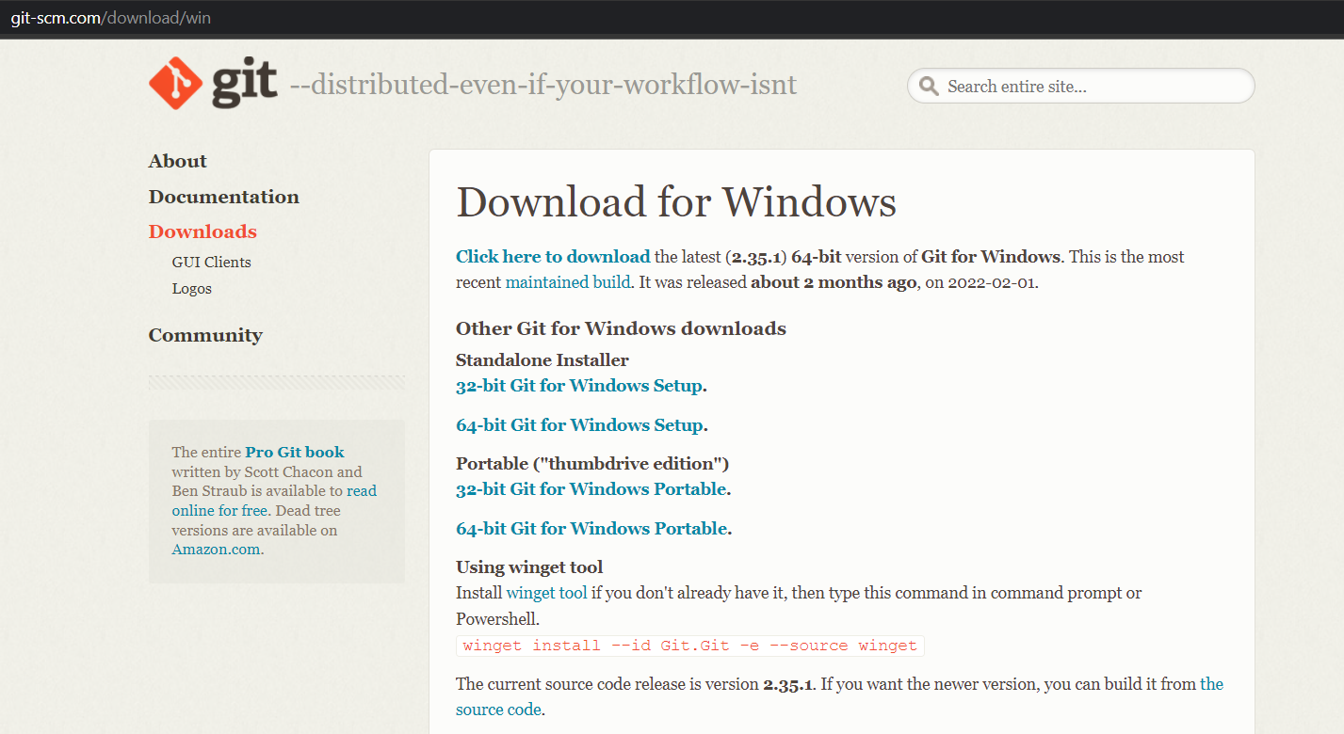

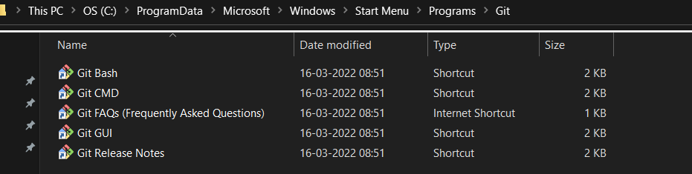

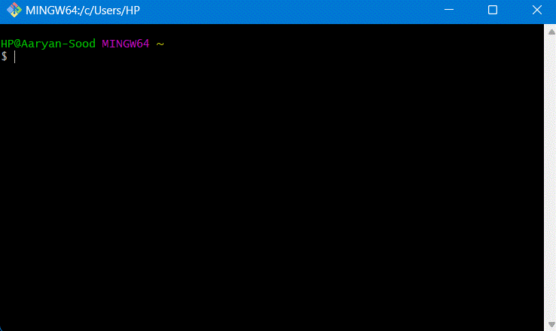

**Experiment No. 02**

**Aim:** Setting up Git-Hub Account

**Theory:**

**What is Git-Hub ->**Git-Hub is a website and cloud-based service (client) that helpsan individual or a developers to store and manage their code. We can also trackas well as control changes to our or public code.

**Advantages of Git-Hub ->**Git-Hub’s has a user-friendly interface and is easy to use .We can connect the git-hub and git but using some commands shown below in figure 001. Without GitHub we cannot use Git because it generally requires a hostand if we are working for a project we need to share it will our team members, which can only be done by making a repository .Additionally, anyone can sign up and host a public code repository for free, which makes GitHub especially popular with open-source projects.

**Procedure:-**

**Step1 :-**

Google (any search engine)

Search for git-hub or (<https://github.com/signup>).

**Step2 :-**

**Snapshots** –

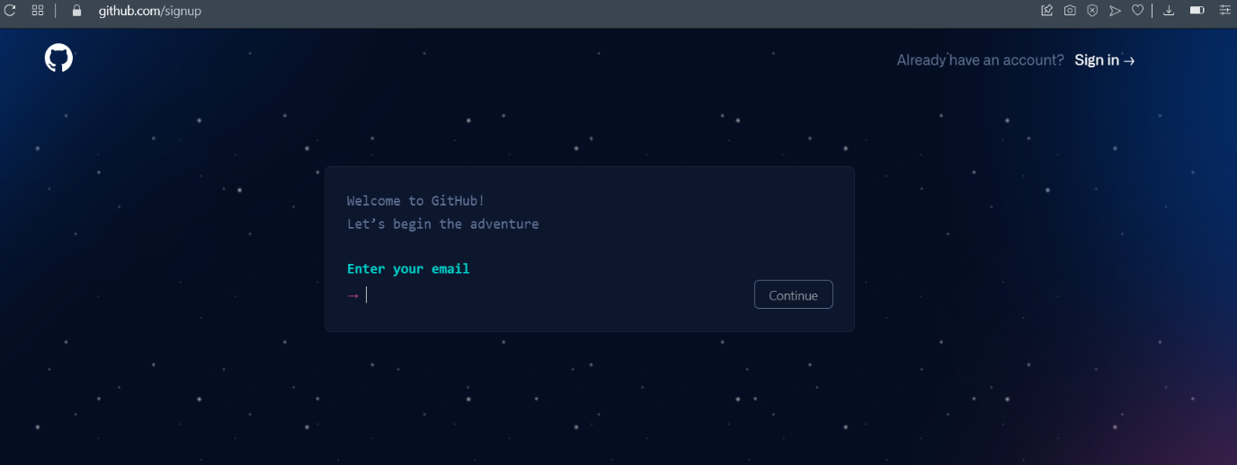

After visiting the link this type of interface will appear, if you already have account you can sign in and if not you can create.

**Sign in into GIT-HUB :-**

You firstly have to make Github ID and then sign-in. Then you will get an interface like in the next step.

**Interface of GitHub :-**

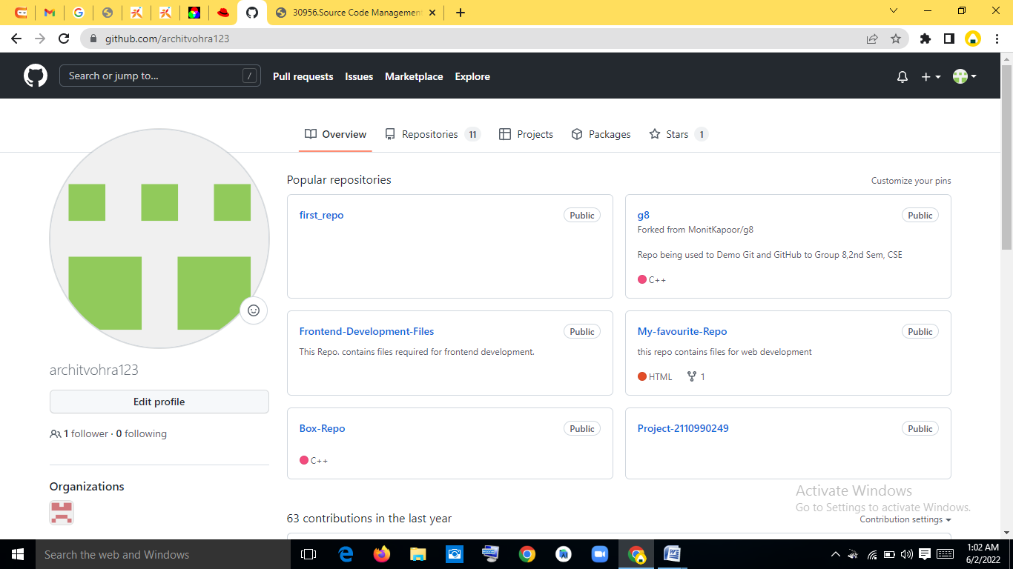

**To link GitHub account with Git bash –**

**For username:-**

git config --global user.name “username in git-hub”

**For user email:-**

git config --global user.email “your email in git-hub”

**To verify:-**

git config user.name

git config user.email

**Snapshot :-**

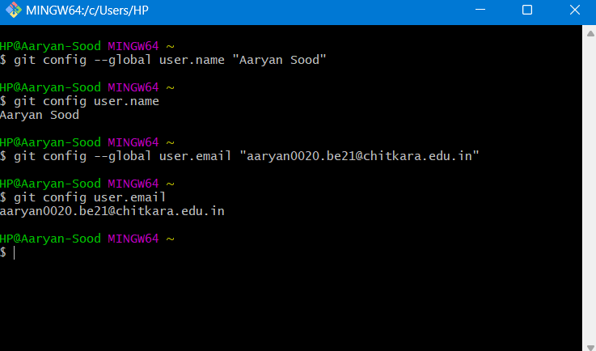

**Experiment No. 03**

**Aim:** Program to Generate log

**Theory:-**

**Logs ->** Logs are nothing but the history which we can see in git by using the code git log.

It contains all the past commits, insertions and deletions in it which we can see any time.

## Why logs -> Logs helps to check that what were the changes in the code or any other file and by whom. It also contains the number of insertions and deletions including at which time it was changed. First of all create a local repository using Git. For this, you have to make a folder in your device, right click and select “Git Bash Here”. This opens the Git terminal. To create a new local repository, use the command “gitinit” and it creates a folder.git

* When we use GIT for the first time, we have to give the user name and email so that if I am going to change in project, it will be visible to all.

For this, we use command 🡪

**“git config --global user.name *Name*”**

**“git config --global user.email*email*”**

For verifying the user’s name and email, we use 🡪

**“git config --global user.name”**

**“git config --global user.email”**

**Some Important Commands:**

* **ls🡪**It gives the file names in the folder.
* **ls -lart🡪**Gives the hidden files also.
* **git status🡪**Displays the state of the working directory and the staged snapshot.
* **touch filename 🡪**This command creates a new file in the repository.
* **Clear 🡪**It clears the terminal.
* **rm -rf .git🡪**It removes the repository.
* **git log 🡪**displays all of the commits in a repository's history
* **git diff 🡪**It compares my working tree to staging area.
* Now, we have to create some files in the repository. Suppose we created index.html Now type git status:  
    
  **git log:**The git log command displays a record of the commits in a Git repository. By default, the git log command displays a commit hash, the commit message, and other commit metadata.

**Snapshots –**

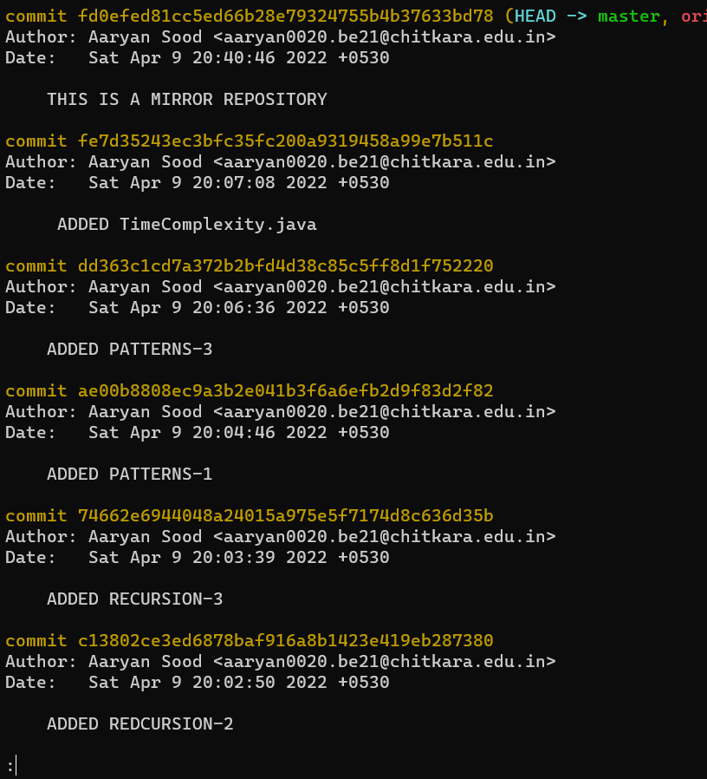

**Experiment No. 04**

**Aim:** Create and visualize branches

**Create branches :-**

* The main branch in git is called as master branch. But we can make branches out of this main master branch. All the files present in master can be shown in branch but the file which are created in branch are not shown in master branch. We can also merge both the parent (master) and child (other branches).  
    
  **Branching:** A branch in Git is an independent line of work(a pointer to a specific commit). It allows users to create a branch from the original code (master branch) and isolate their work. Branches allow you to work on different parts of a project without impacting the main branch.

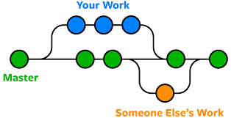

Let us see the command of it:

Firstly, add a new branch, let us suppose the branch name is activity1.

For this use command 🡪

* **git branch name [**adding new branch**]**
* **git branch [**use to see the branch’s names**]**
* **git checkout *branch name* [**use to switch to the given branch**]**
* In this you can see that firstly ‘git branch’ shows only one branch in green colour but when we add a new branch using ‘git branch act1’, it shows 2 branches but the green colour and star is on master. So, we have to switch to act1 by using ‘git checkout act1’. If we use ‘git branch’, now you can see that the green colour and star is on act1. It means you are in activity1 branch and all the data of master branch is also on act1 branch. Use “ls” to see the files.
* Now add a new file in activity1 branch, do some changes in file and commit the file.

**Syntax:-**

1. For creating a new branch.

git branch name of branch

**Snapshots –**

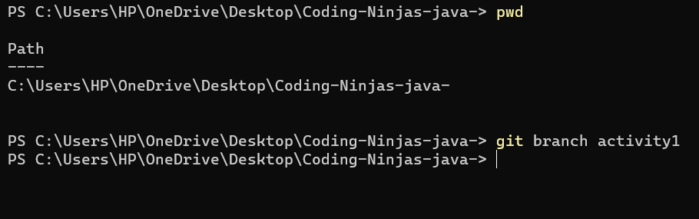

1. We can also check how many branches we have.

git branch

**Snapshots :-**

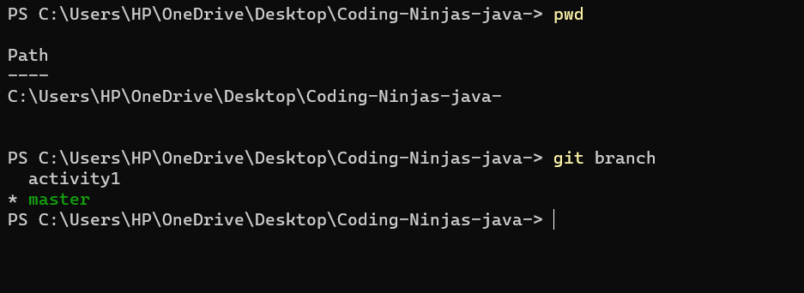

1. To change the present working branch.

git checkout name of branch.

**Snapshots –**



**Visualizing branches :-**

To visualize I have created a new file in a new branch activity 1 instead of master branch.

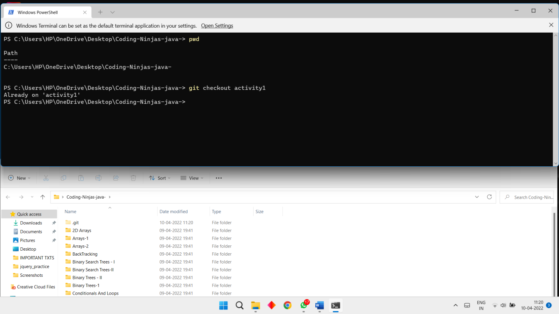

After this I have done the 3 step architecture which is tracking the file , send it to stagging

area and finally we can role back to any previously saved version of this file.

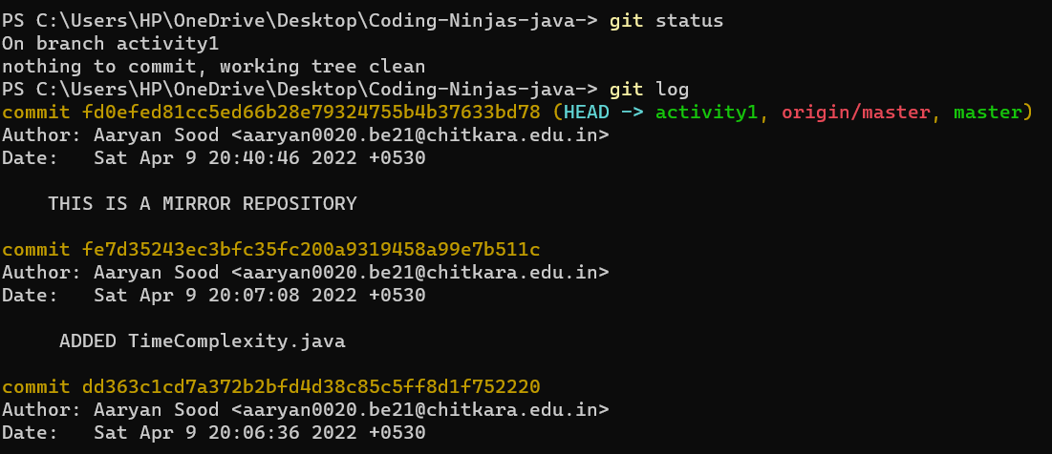

After this we will change the branch from activity1 to master, but when I will switch to the

master branch there will not be the same file in the master , it will not show the new file in

the master branch.

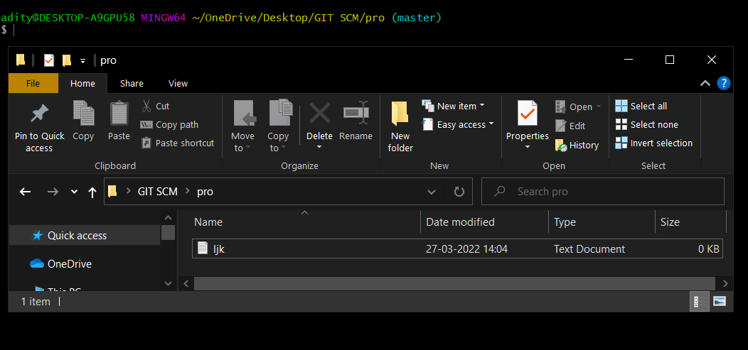

In this way we can create and change different branches . We can also merge the branches

by using git merge command.

**Experiment No. 05**

**Aim:** Git lifecycle description

**Theory:**

**Stages in GIT Life Cycle->**Files in a Git project have various stages like Creation, Modification, Refactoring, and Deletion and so on. Irrespective of whether this project is tracked by Git or not, these phases are still prevalent. However, when a project is under Git version control system, they are present in three major Git states in addition to these basic ones. Here are the three Git states:

* Working directory
* Staging area
* Git directory

**Working Directory ->**

Consider a project residing in your local system. This project may or may not be tracked by Git. In either case, this project directory is called your Working directory.

### **Staging Area ->**

**Staging area is the playground where you group, add and organize the files to be committed to Git for tracking their versions.**

**Git Directory ->**

Now that the files to be committed are grouped and ready in the staging area, we can commit these files. So, we commit this group of files along with a commit message explaining what is the commit about. Apart from commit message, this step also records the author and time of the commit. Now, a snapshot of the files in the commit is recorded by Git. The information related to this commit is stored in the Git directory.

**Remote Repository-> means mirror or clone of the local Git repository in GitHub**. And **pushing means uploading the commits from local Git repository to remote repository hosted in GitHub.**

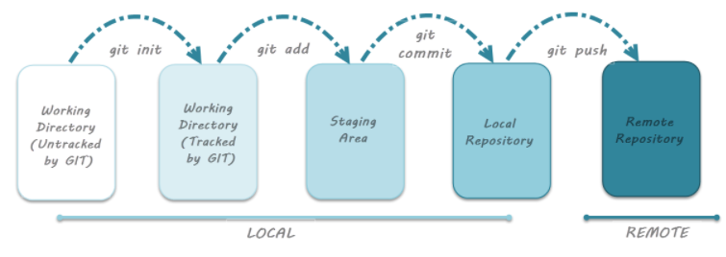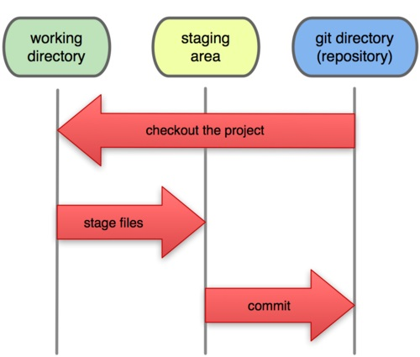

**Snapshots –**

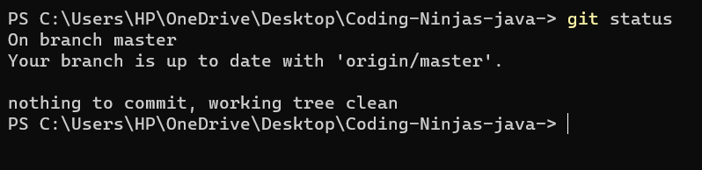

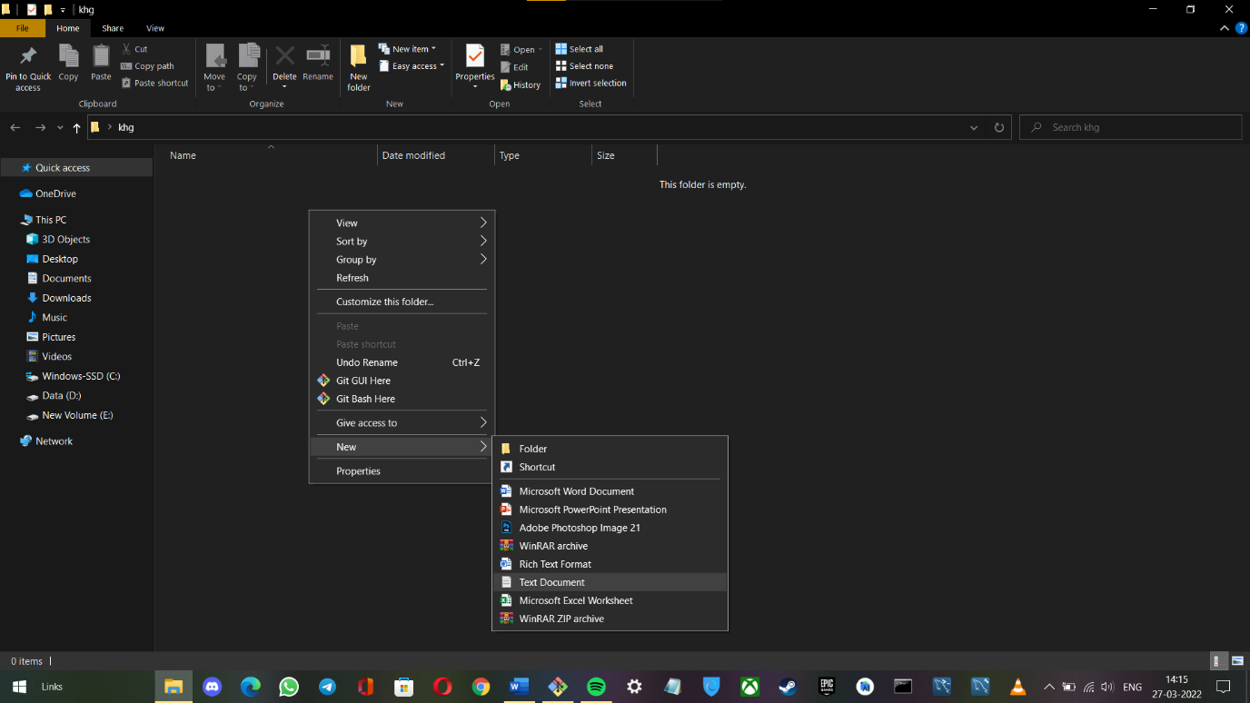

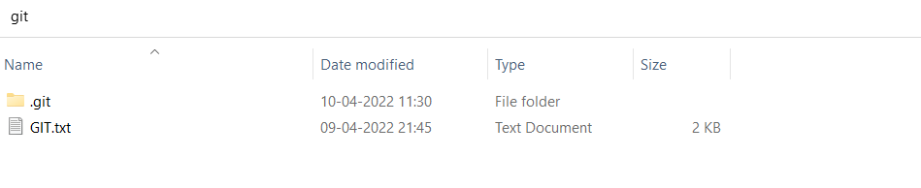

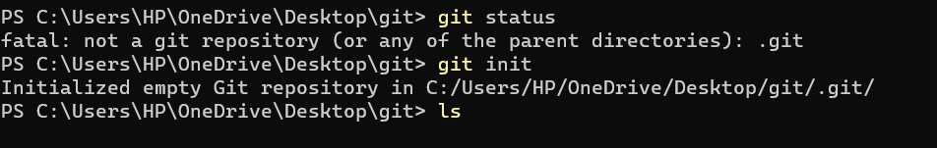

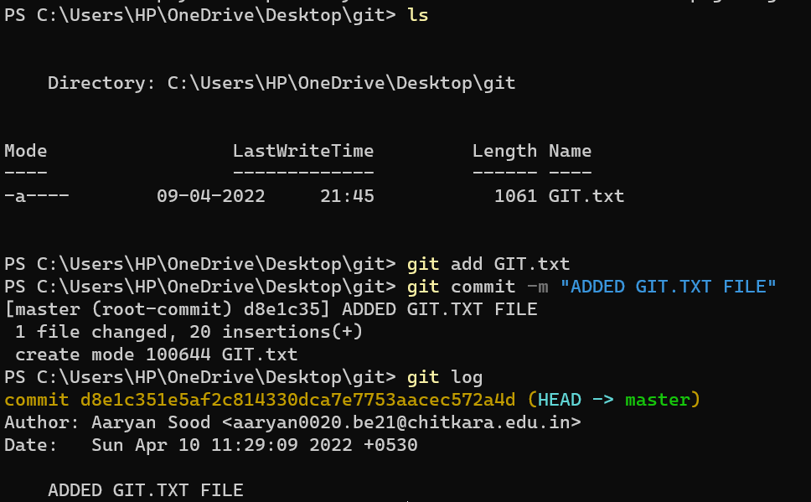

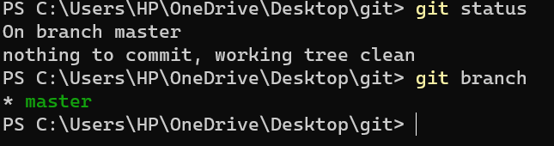

**TASK 1.2**



Subject Name: **Source Code Management**

Subject Code: **CS181**

Cluster: **BETA**

Department: **CSE**



|  |  |  |
| --- | --- | --- |
| **Submitted By:**  **Archit Vohra**  2110990249  **G-08/B** |  | **Submitted To:**  **Mr. Monit Kapoor** |



**Source Code Management (Task 1.2)**

|  |  |  |
| --- | --- | --- |
| S.No | Task Title | Page No. |
| 1. | **Add collaborators on GitHub Repo** | 3 - 6 |
| 2. | **Fork and Commit** | 7 - 8 |
| 3. | **Merge and Resolve conflicts created due to own activity and collaborators activity.** | 9 - 9 |
| 4. | **Reset and Revert** | 10 - 11 |



**Add collaborators on GitHub Repo**

1. Create a New Repository.

A repository is like a folder for your project. You can have any number of public and

private repositories in your user account. Repositories can contain folders and files,

images, videos, spreadsheets, and data sets, as well as the revision history for all files in

the repository. For more information, see "About repositories."

When you create a new repository, you should initialize the repository with a README

file to let people know about your project. For more information, see "Creating a new

repository."

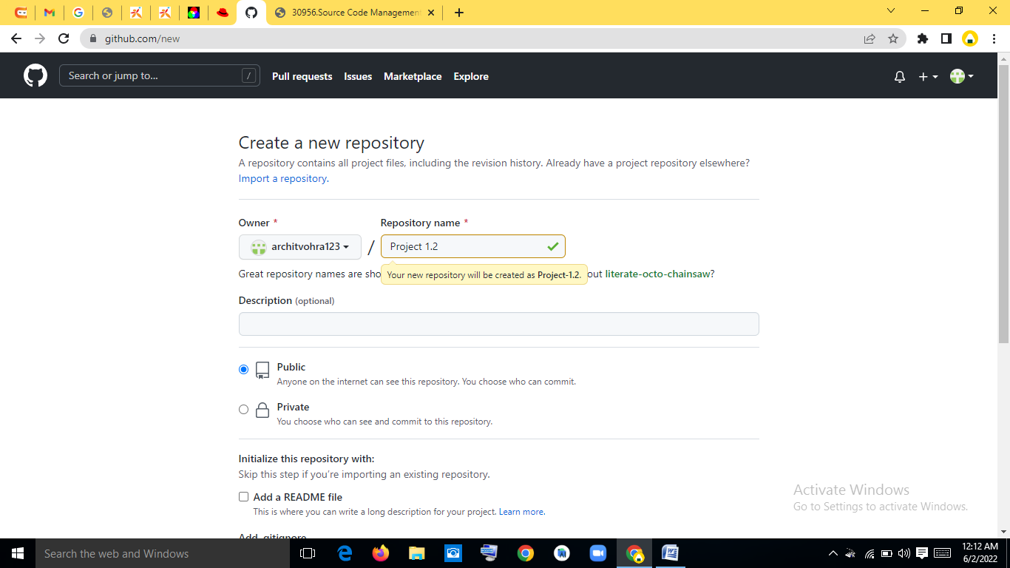

2. Now Copy the HTTP link of your repo and paste it on your ‘Git CLI’, and merge the local repo in remote repo.

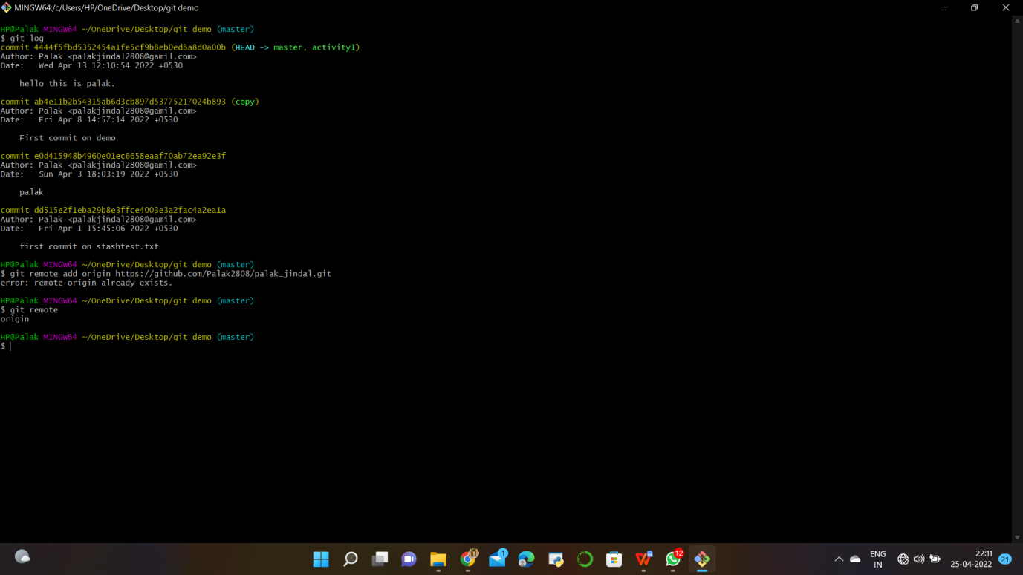

3. Go to Collaborators in Repo Setting , Add the username or email of Collaborator you want to add in your Repo.

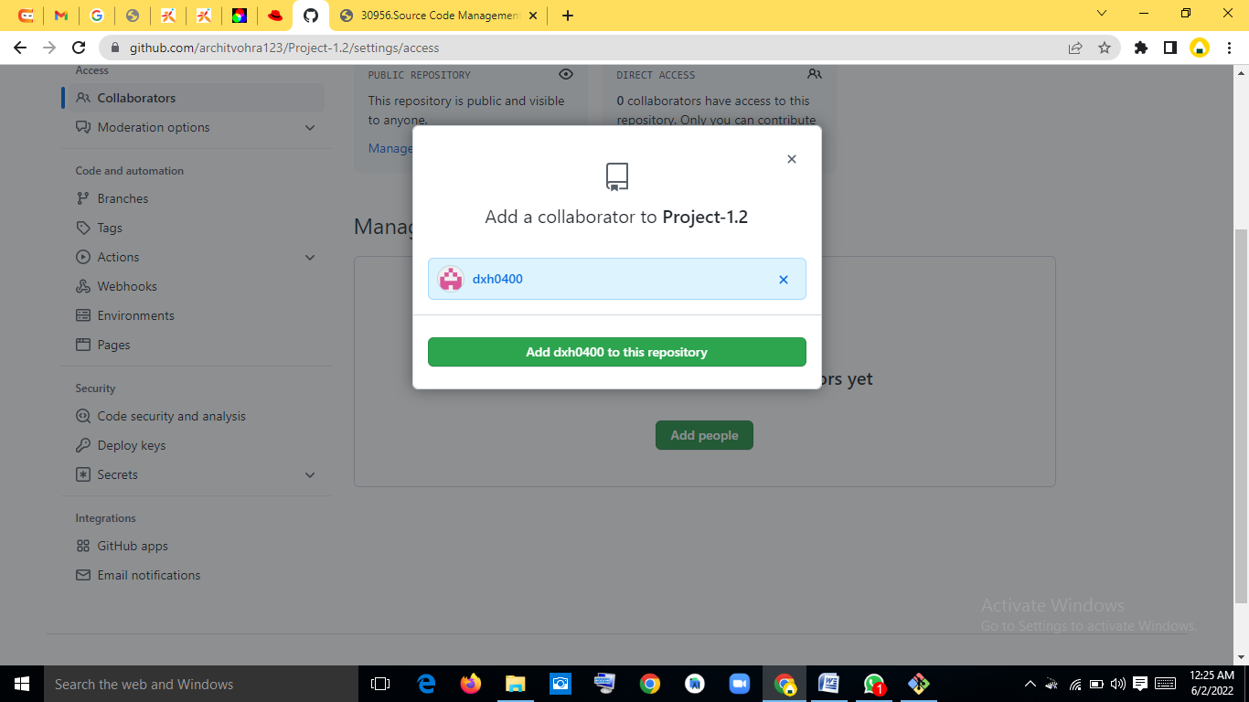



4. Invitation Mail is sent to the Collaborator, The collaborator has to accept this Invitation.

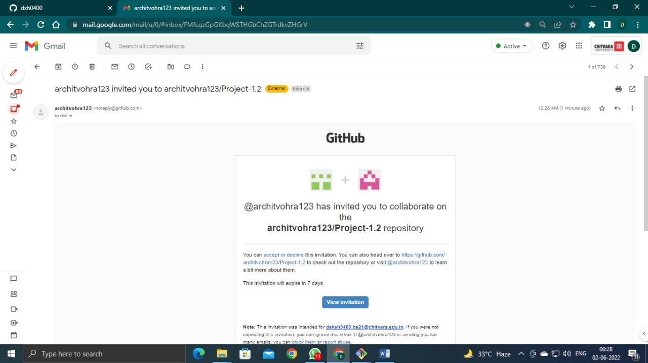

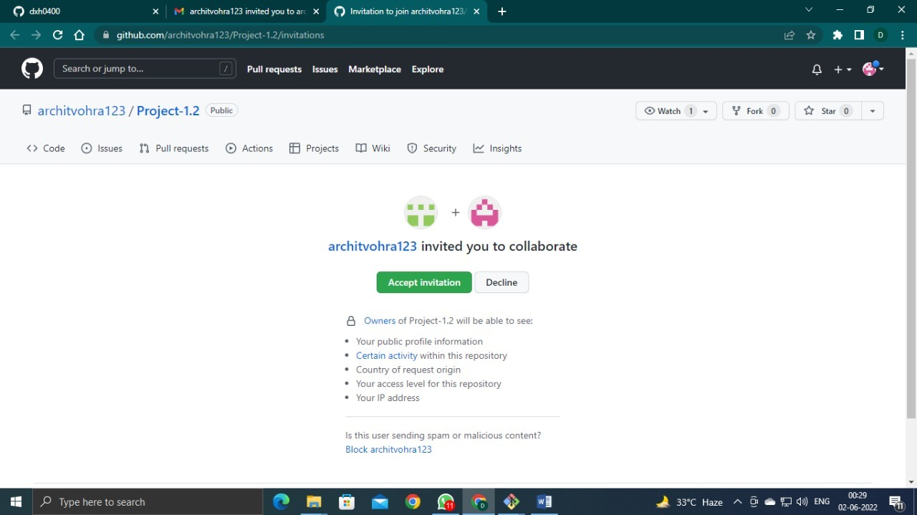



5. New Collaborator has now access to this Repository.

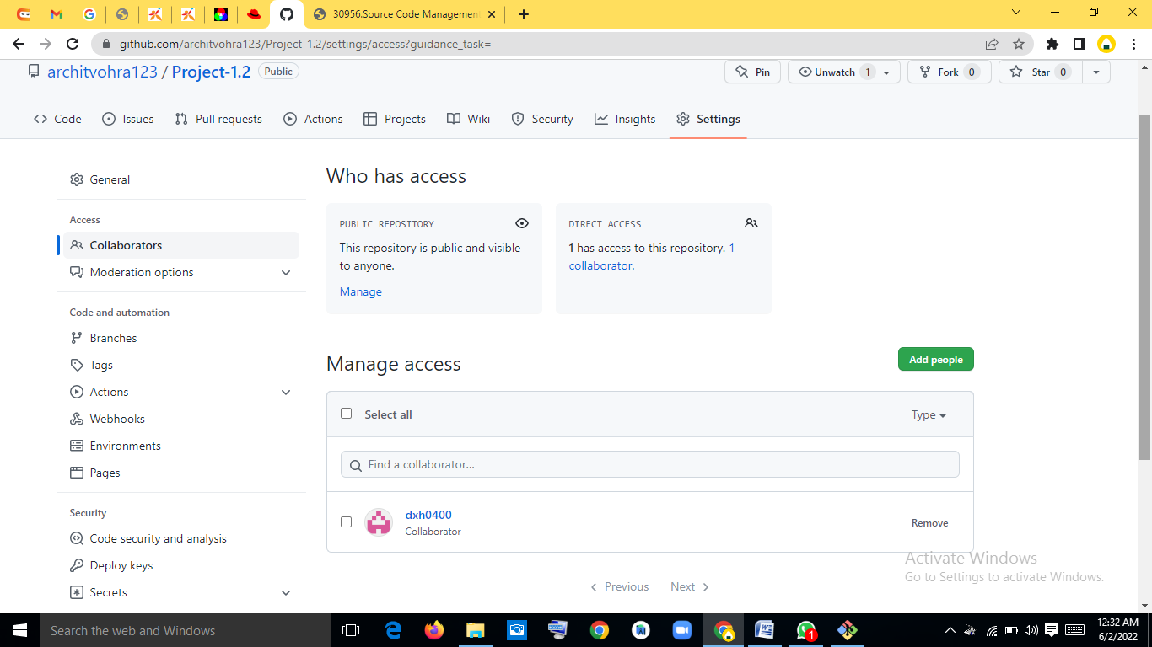



**Fork and Commit**

**Fork:-** A Fork is copy of a repository . Forking a repository allows you to freely experiment with changes without affecting the original Project.

1. Create a New Repo (or Folder) and Initialized the Git repository , Using ‘git init’ command. And add origin of your remote Repo to local Repo.

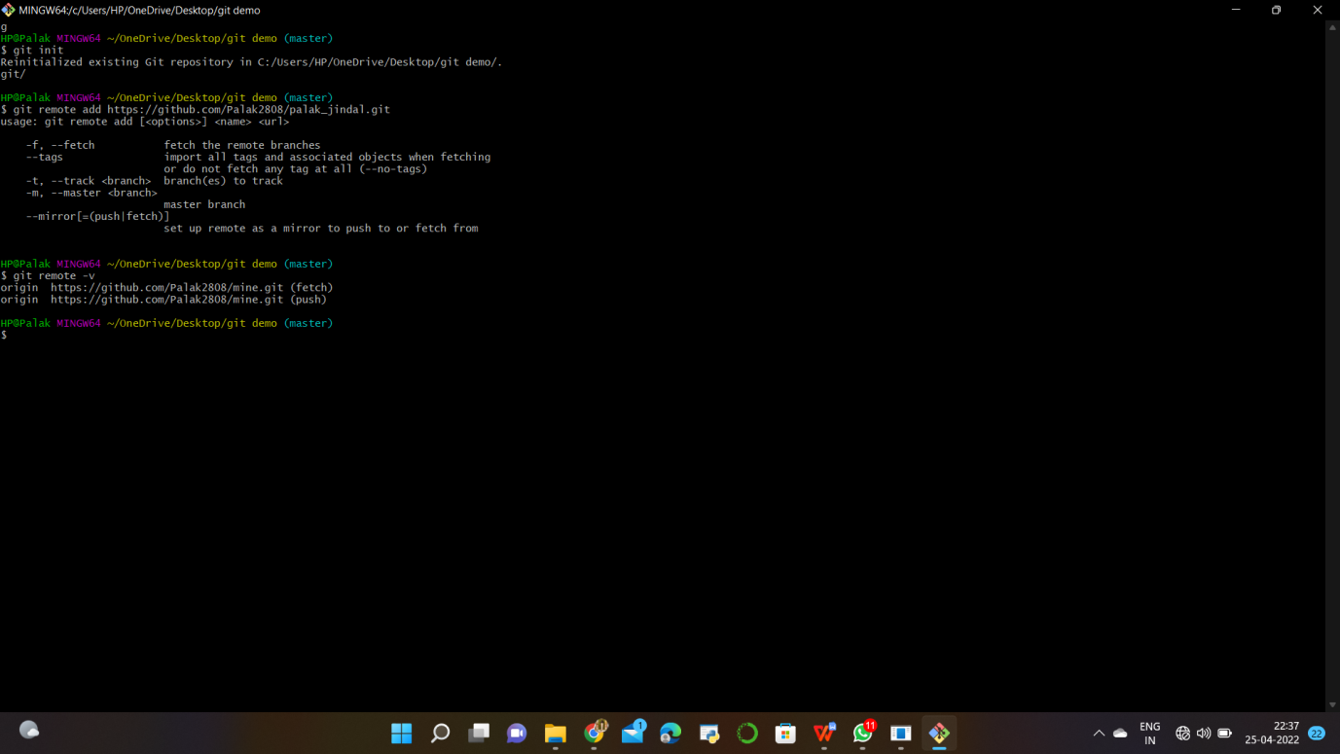

2. Type https://github.com/architvohra123.git on CLI.

**Git pull <url>🡪**This command is used to fetch the remote repo or to clone the repo.

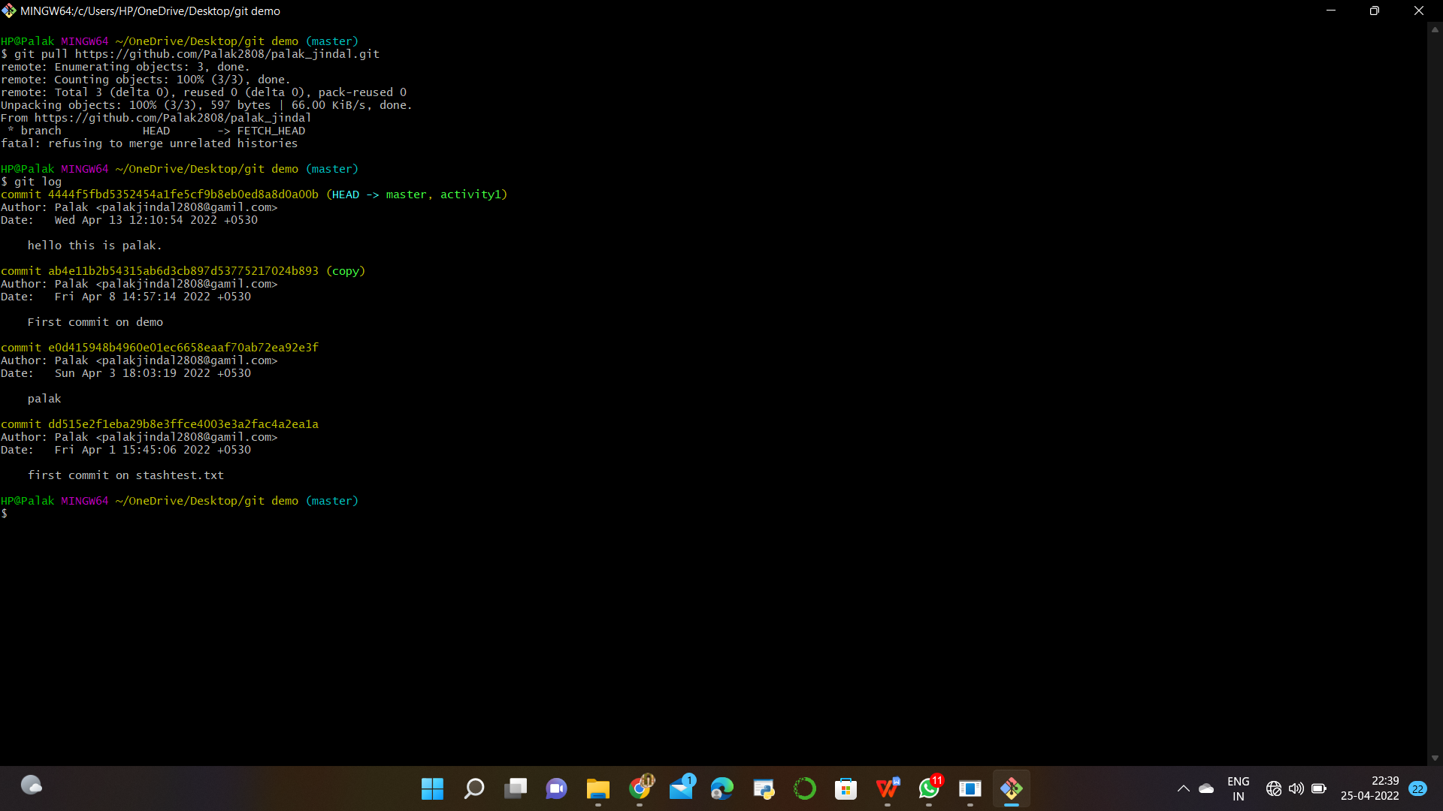

1. Create a new Branch “Feature-1”. Open the file and do changes in it and commit it.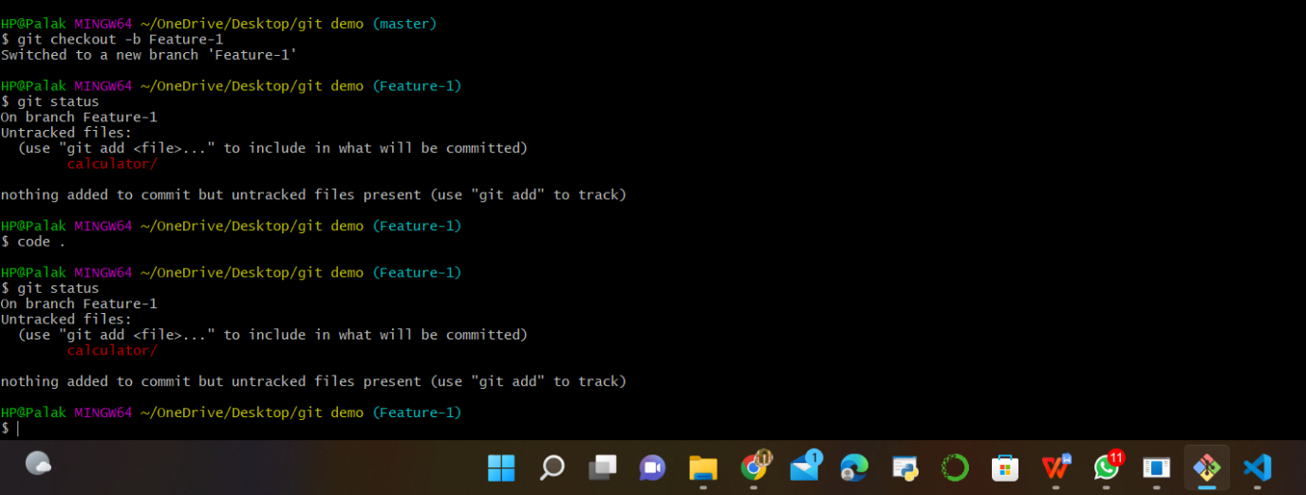

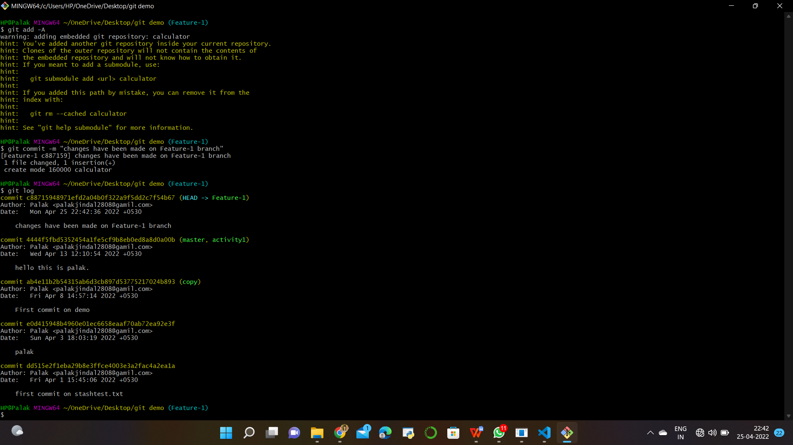

**Commit is made on the fork Repo.**



**Merge and Resolve conflicts created due to own activity and collaborators activity.**

1. Do changes in master branch and commit those change. And checkout to “Feature-1” branch and again do changes and commit it. Now checkout to master branch and merge the Feature-1 branch in master.

**Commit in Master Branch**

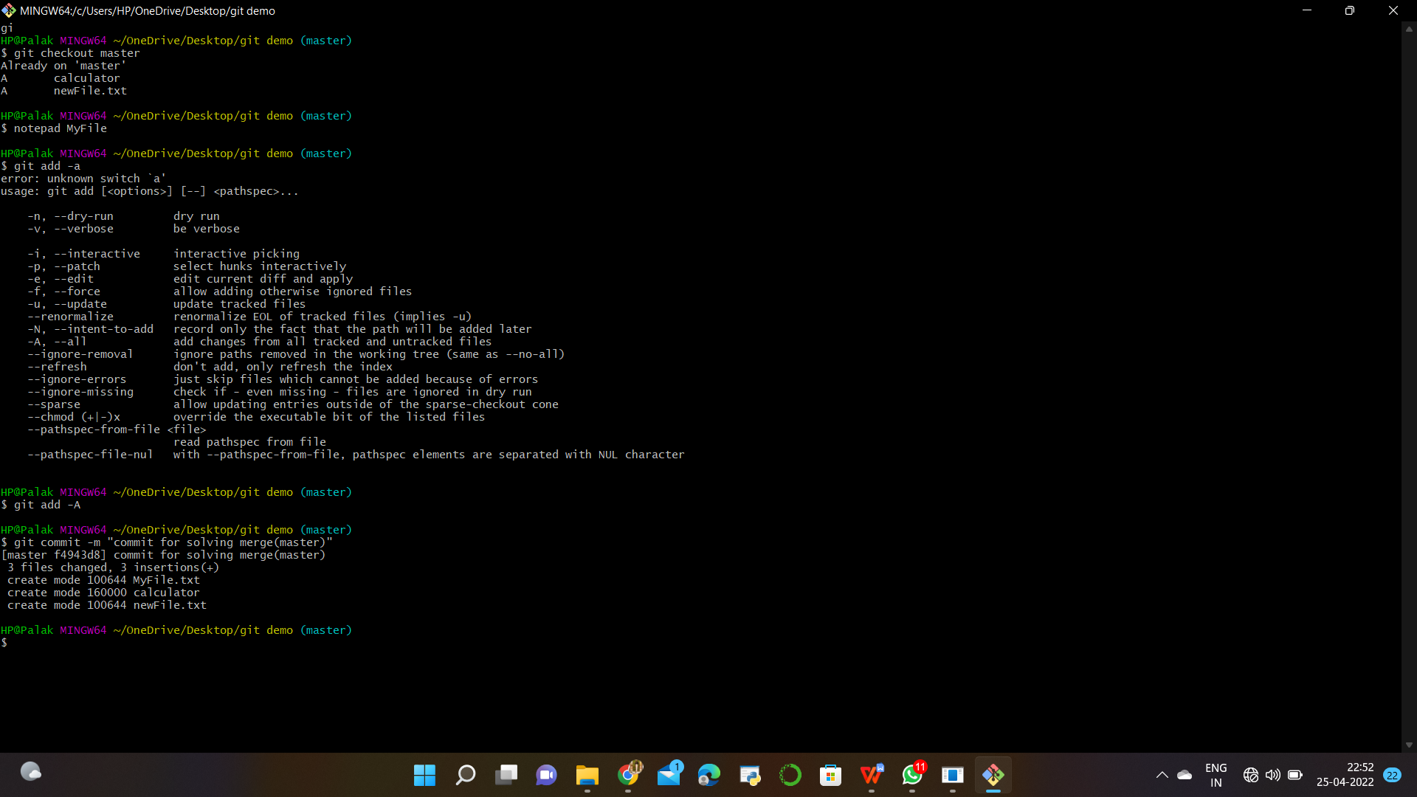

**Commit in Feature-1 Branch**

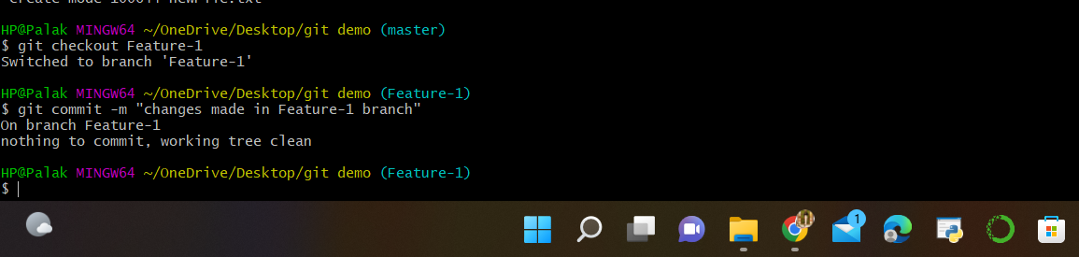

**Due To My Activities , faces conflict during Merging**



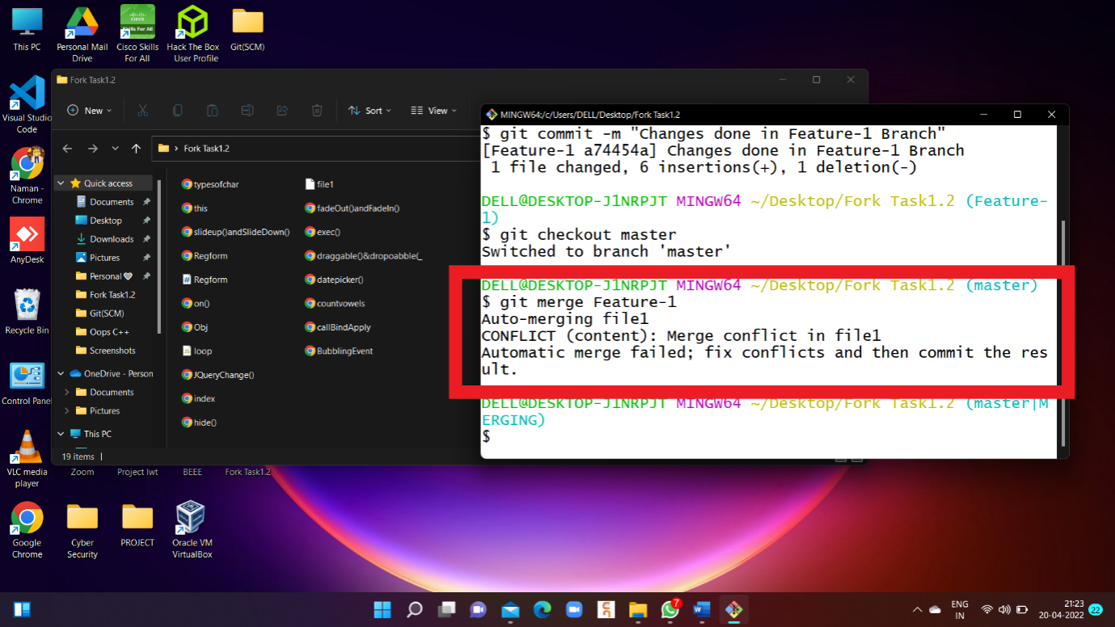

2. Use Command “Git mergetool” to solve the conflict

**git-mergetool - Run merge conflict resolution tools to resolve merge conflicts**

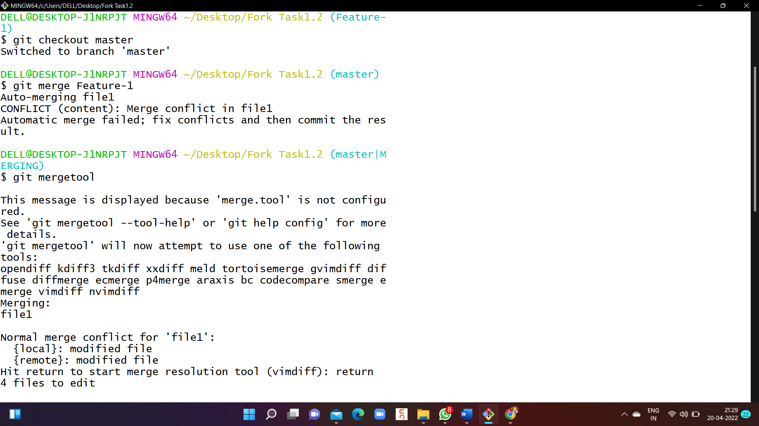

2. Press “I” to insert, after insertion. Press “**:wq**”. The merge conflict is solved and our Feature-1 branch is merged to master branch.



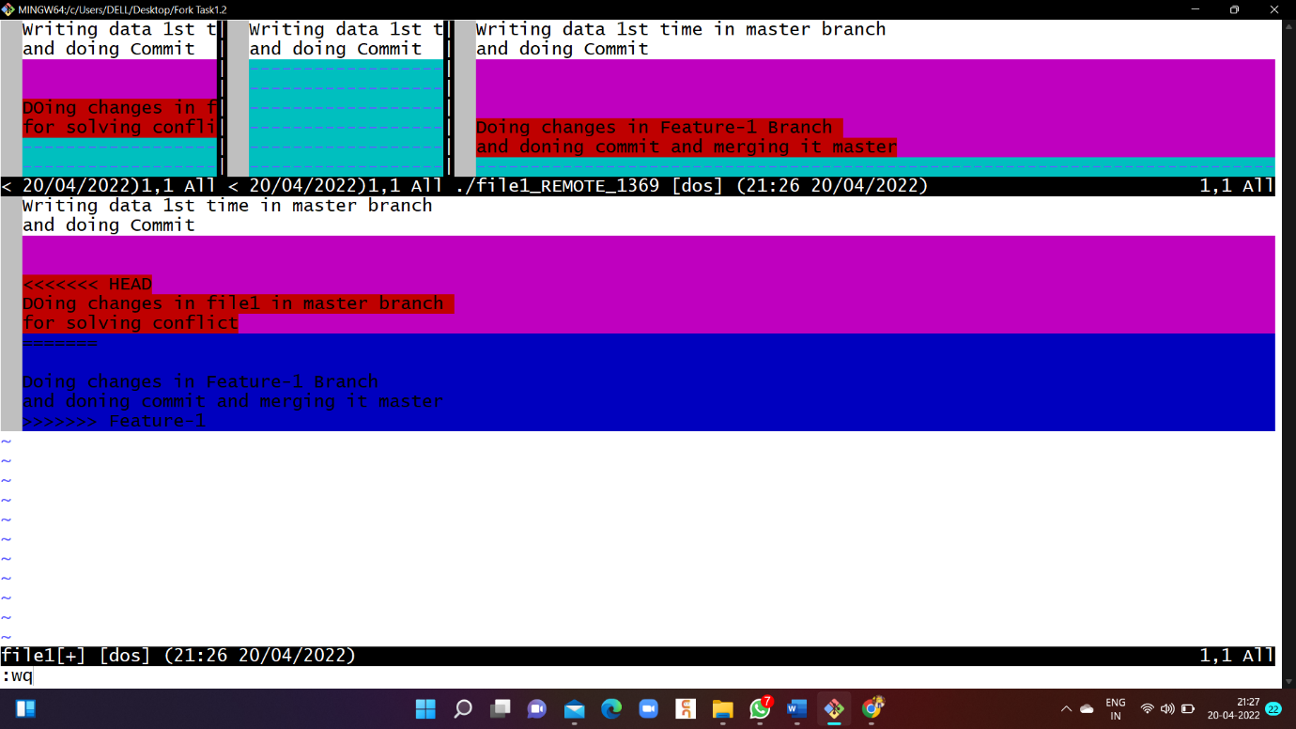



**Reset and Revert**

**git-revert - Revert some existing commits.**

1.On GitBash CLI , Type command “git Commad <Commit id>” . It revert the changes that done before Commit.

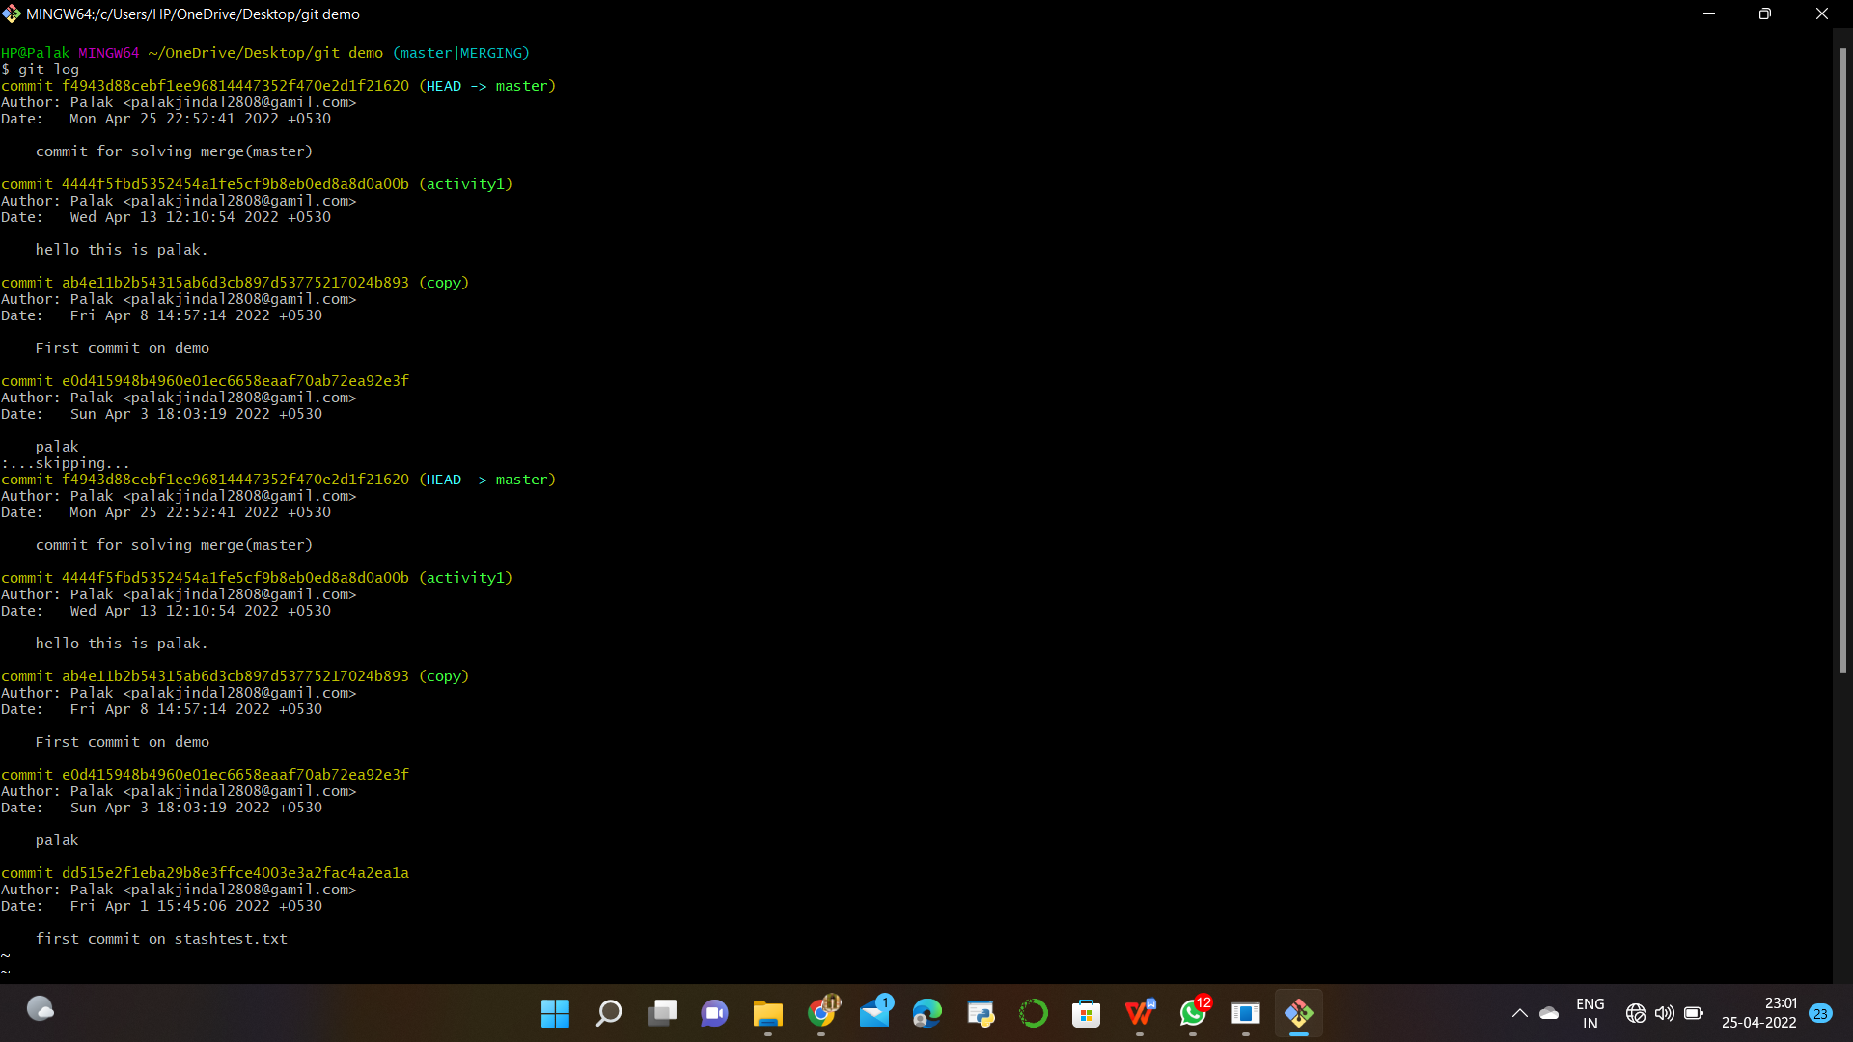

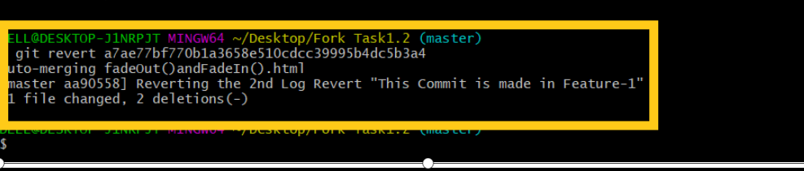

**git revert HEAD~3 :-**

**Revert the changes specified by the fourth last commit in HEAD and create a new commit with the reverted changes.**

**git-reset - Reset current HEAD to the specified state.**

At a surface level, git reset is similar in behavior to git checkout. Where git checkout solely operates on the HEAD ref pointer, git



reset will move the HEAD ref pointer and the current branch ref pointer. To better demonstrate this behavior consider the following example:

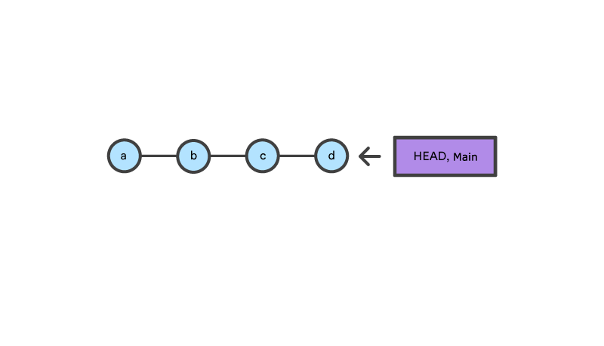

This example demonstrates a sequence of commits on the main branch. The HEAD ref and main branch ref currently point to commit d. Now let us execute and compare, both git checkout b and git reset b.

Git Reset

reset is the command we use when we want to move the repository back to a previous commit, discarding any changes made after that commit.

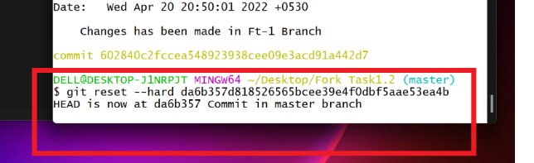

***SUMMARY***

The tasks performed in all are listed below:

1. Add collaborators on GitHub Repo
2. Fork and Commit
3. Merge and Resolve conflicts created due to own activity and collaborators activity.
4. Reset and Revert

A Project report

on

**“Project Title”**

with

**Source Code Management**

(CS181)

Submitted by

Archit Vohra 2110990249 G8/B

And team members

* Aftab Alam –G8
* Daksh Sachdeva-G8
* Arshdeep Singh-G8



**Department of Computer Science & Engineering**

Chitkara University Institute of Engineering and Technology, Punjab

Jan- June  
(2021-22)

|  |  |  |  |
| --- | --- | --- | --- |
| Institute/School Name | **Chitkara University Institute of Engineering and Technology** | | |
| Department Name | **Department of Computer Science & Engineering** | | |
| Programme Name | **Bachelor of Engineering (B.E.), Computer Science & Engineering** | | |
| Course Name | **Source Code Management** | Session | **2021-22** |
| Course Code | **CS181** | Semester/Batch | **2nd/2021** |
| Vertical Name | **Beta** | Group No | G-08 |
| Course Coordinator | **Dr.Navjeet Kaur** | | |
| Faculty Name | **Dr. Monit Kapoor** | | |

Submission

Name: Archit Vohra

Date: 01/06/2022

* Fork with Aftab:

Step1: Choose the repo to fork.

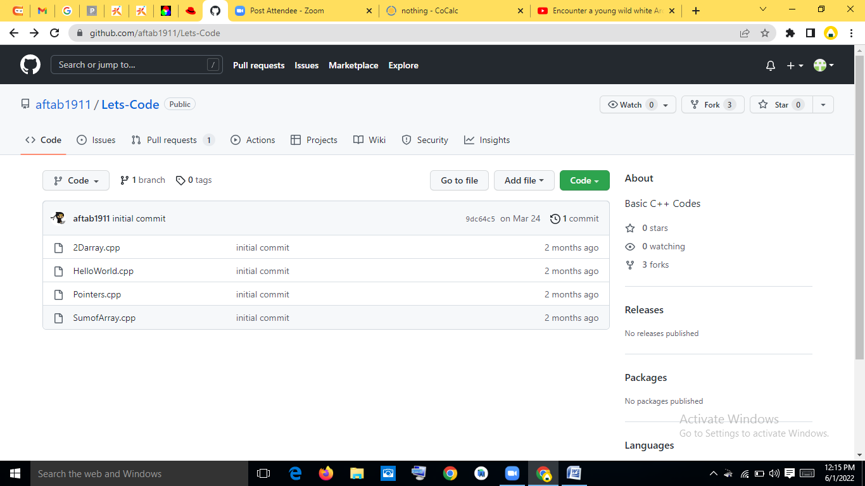

Step 2: Forking that repo by making a new repo in your own github account.

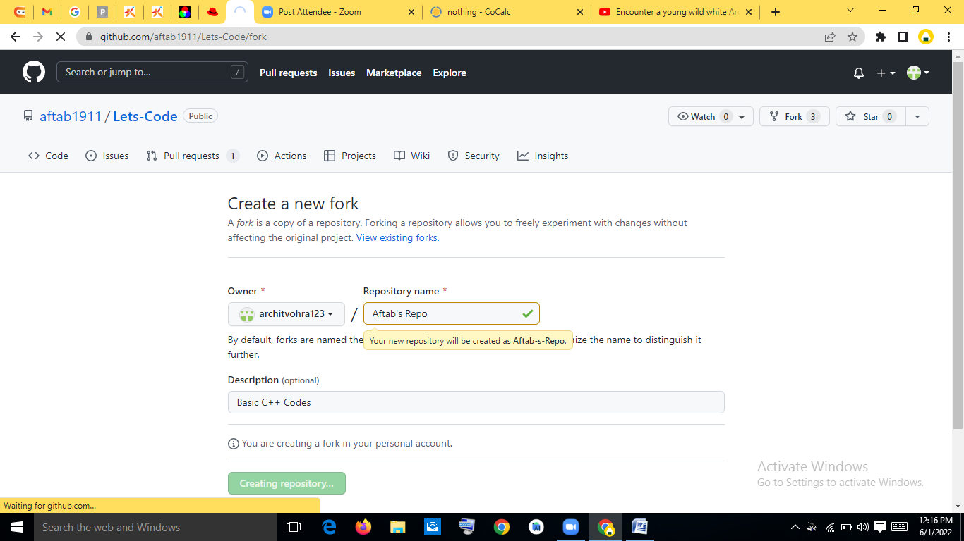

Step3: Now the repo is forked.

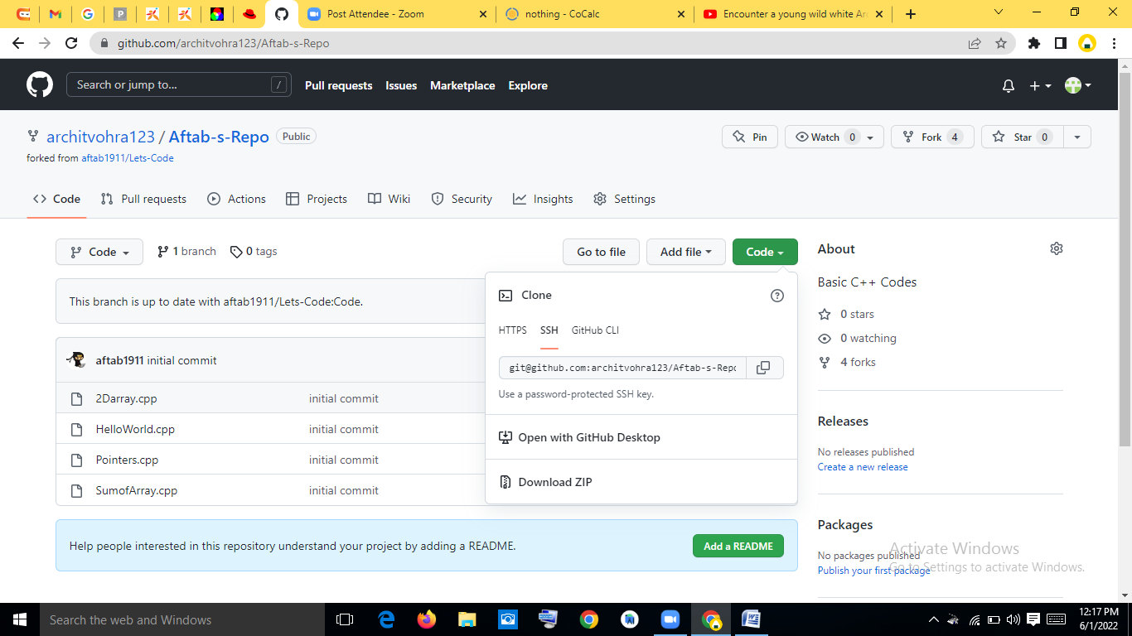

Step4: Now clone that remote repo onto your device.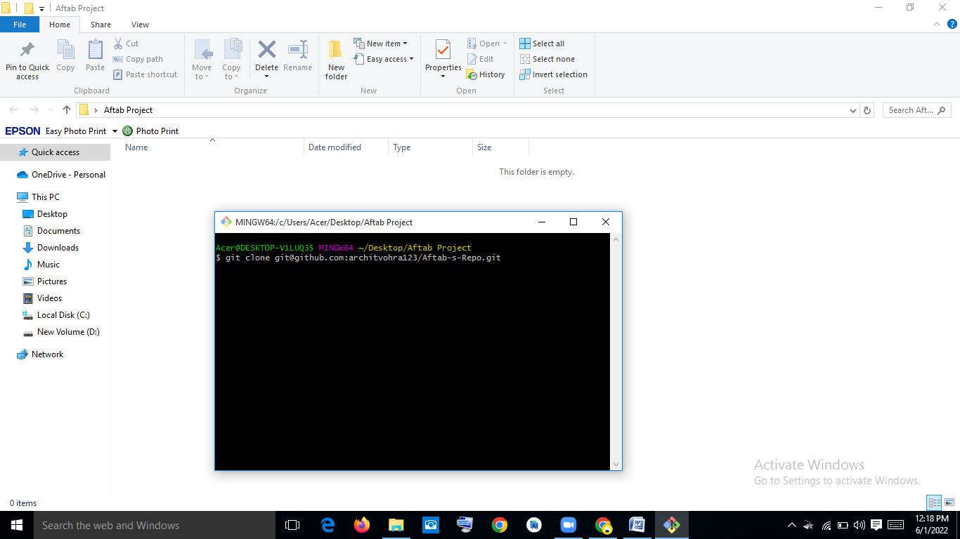

Step5: Make another branch by using “git checkout –b `branch-name`”

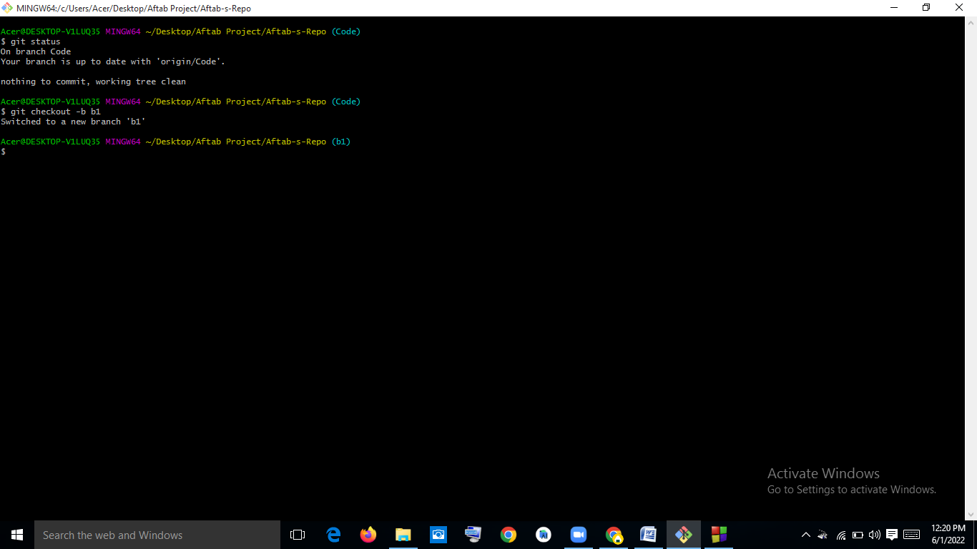

Step6: Now change the code or repo according to you and then commit your changes. Note that everything you are doing upto this point is on the new branch you made at the starting point.

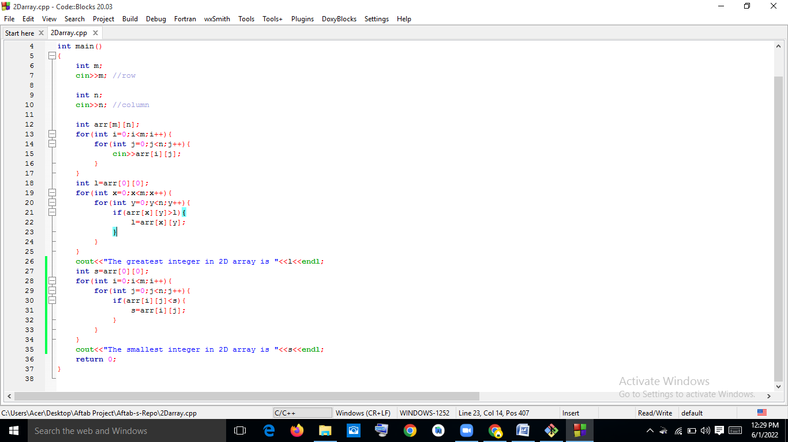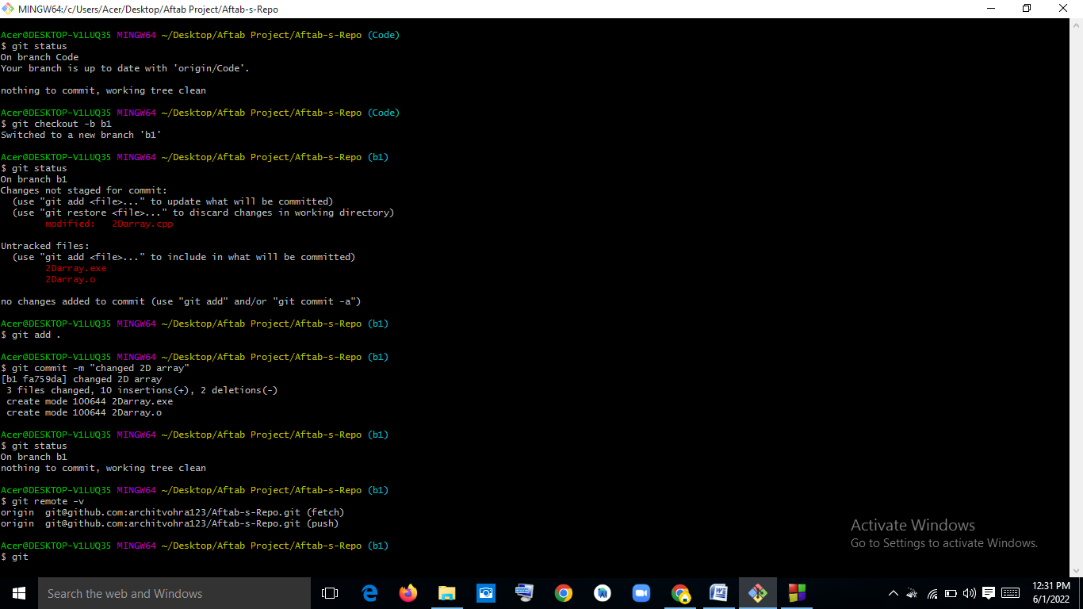

Step7: Now push the repo’s new branch to remote repo by using “git push –u origin `branch-name`”

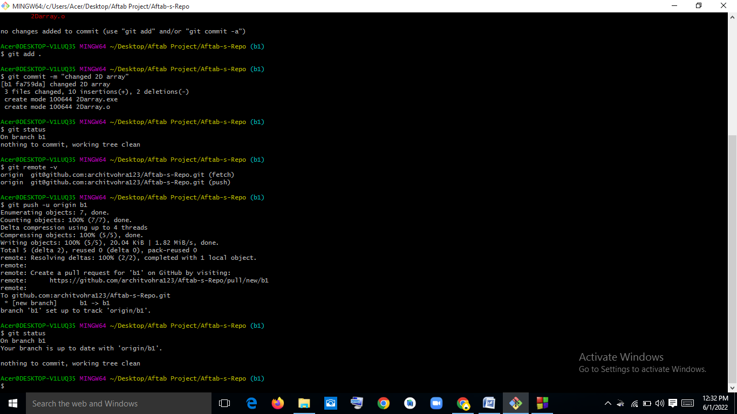

Step8:You will get message like this on your git-hub repo. 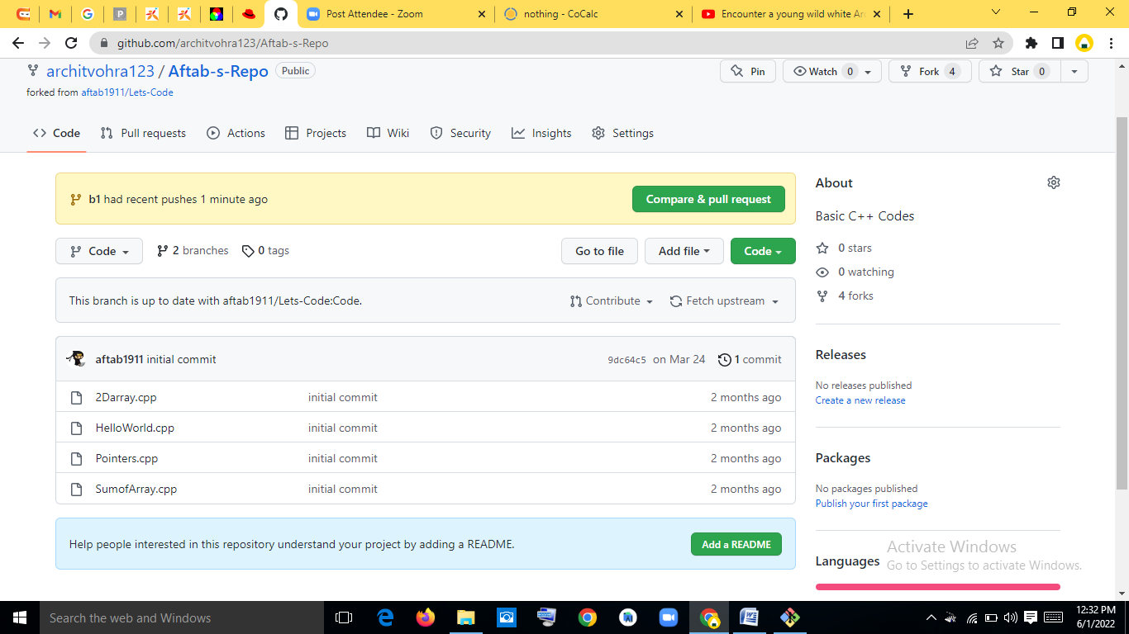

Step-9:Open the pull request, Name it and create the pull request.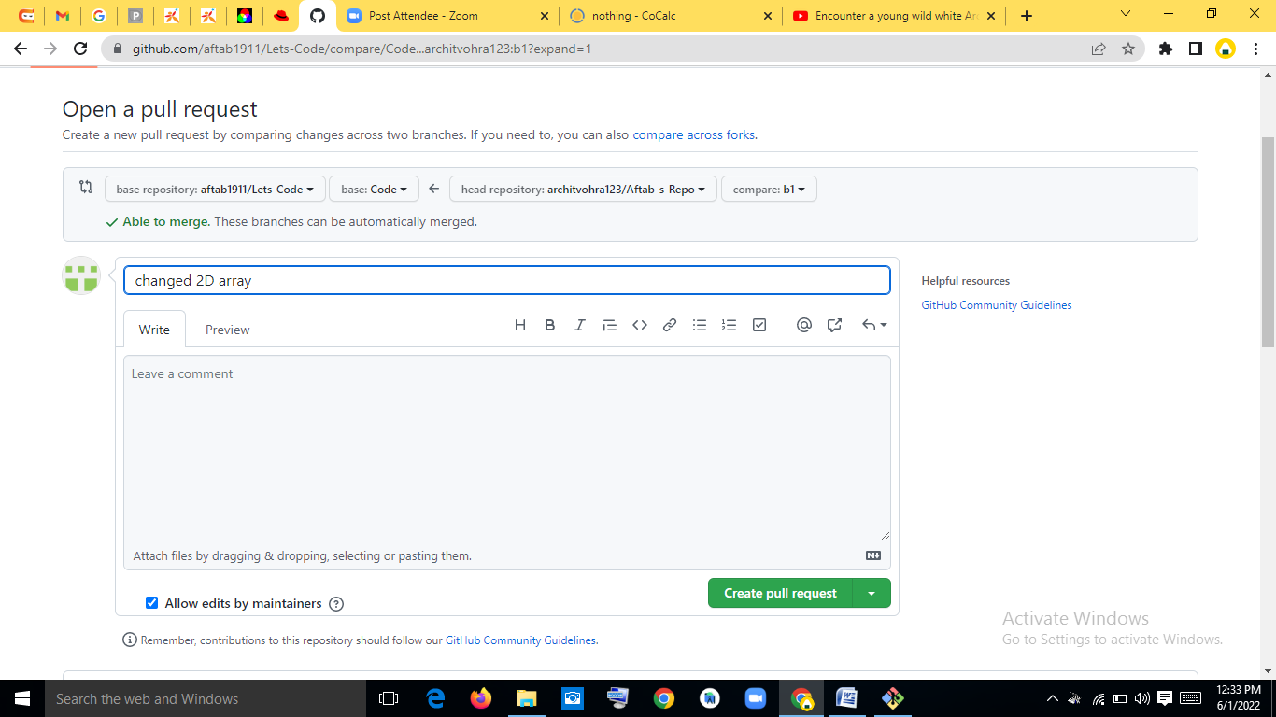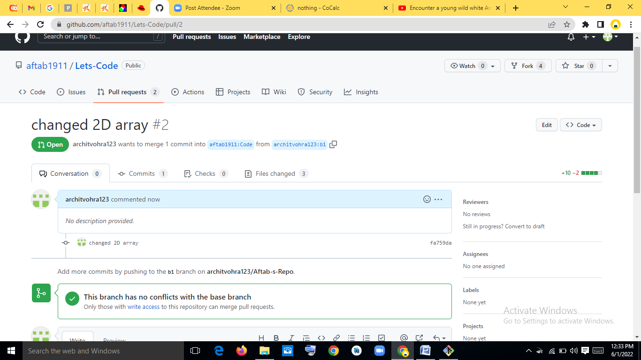

Step 10: Now a pull request will go on to owner’s mail ID regarding the pull request. The owner now accepts it and it automatically merges with the original remote repo. 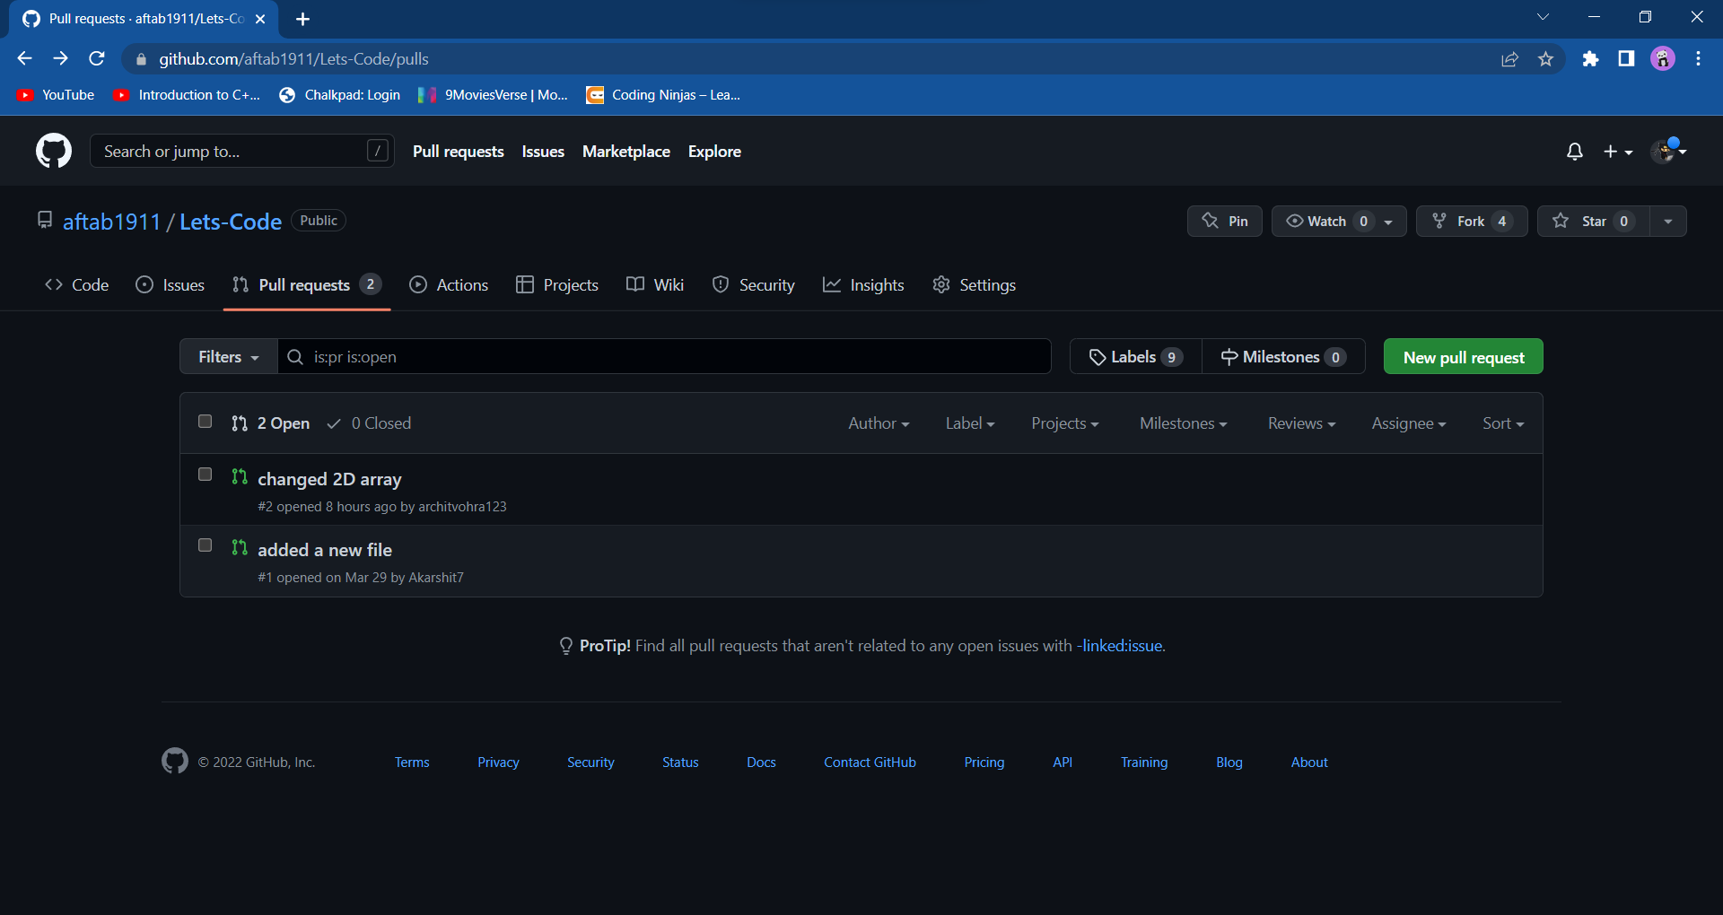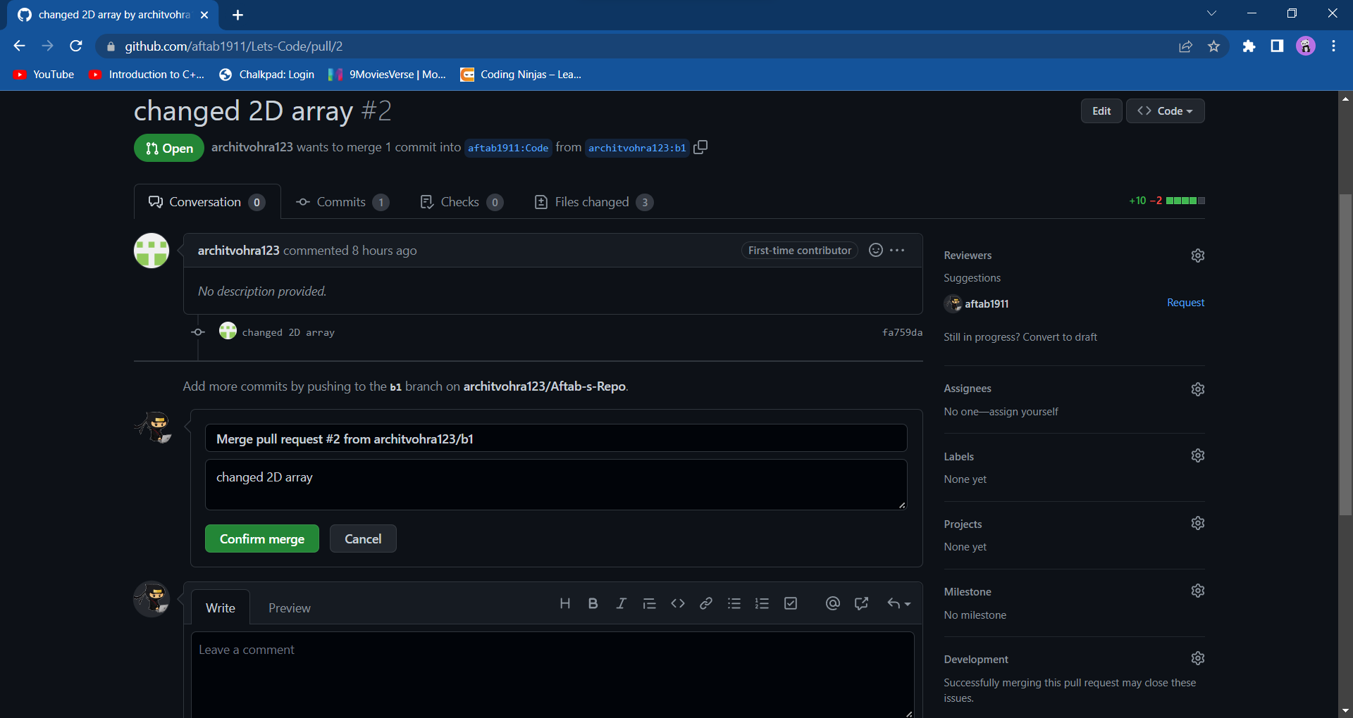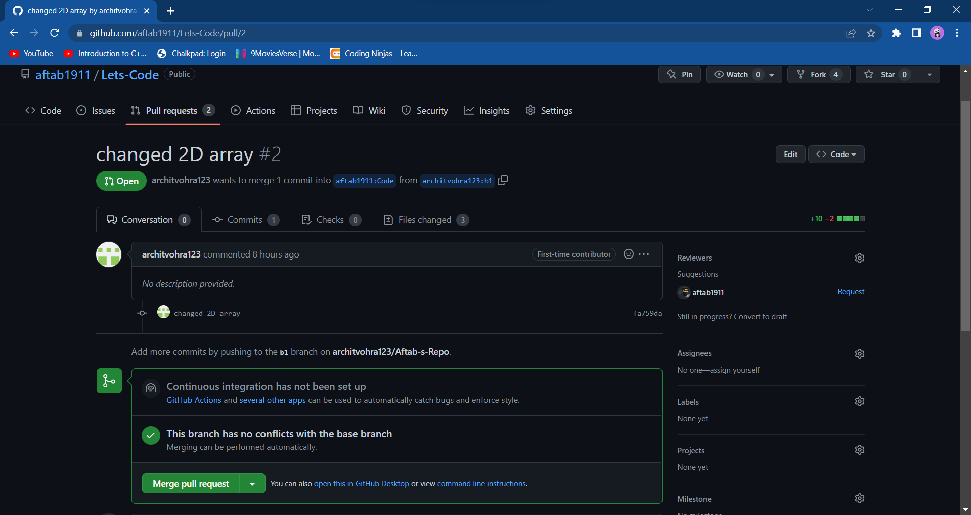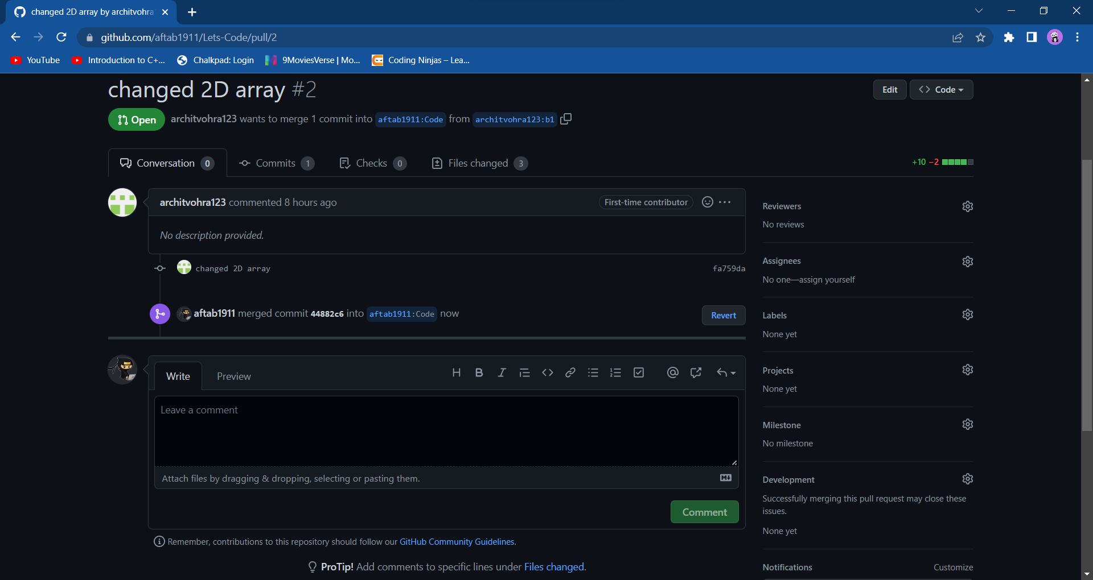

Forking with Daksh:

Step1: Choose the repo to fork.

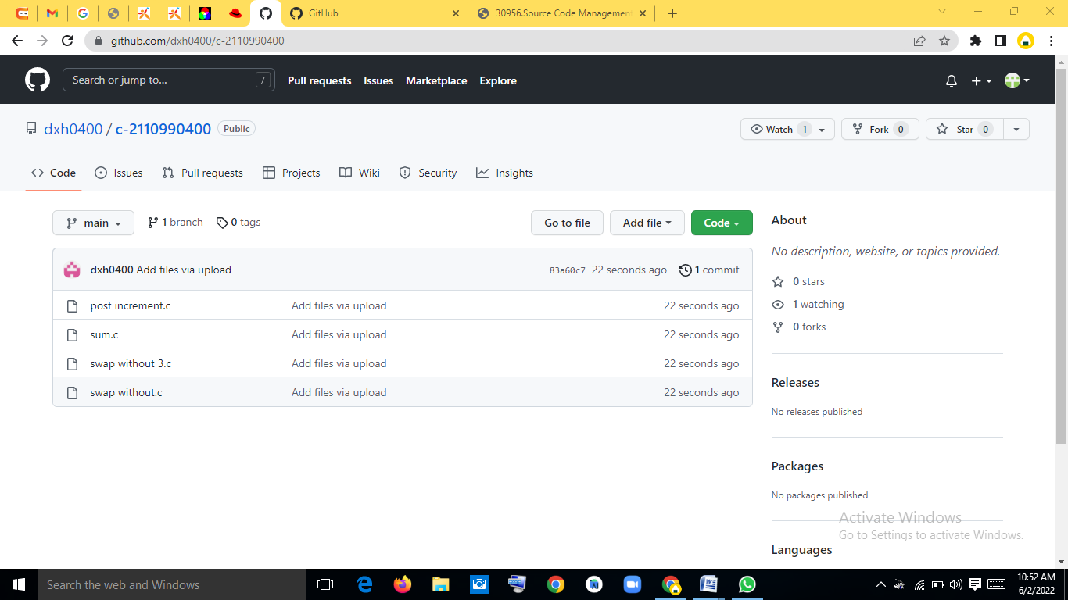

Step 2: Forking that repo by making a new repo in your own github account.

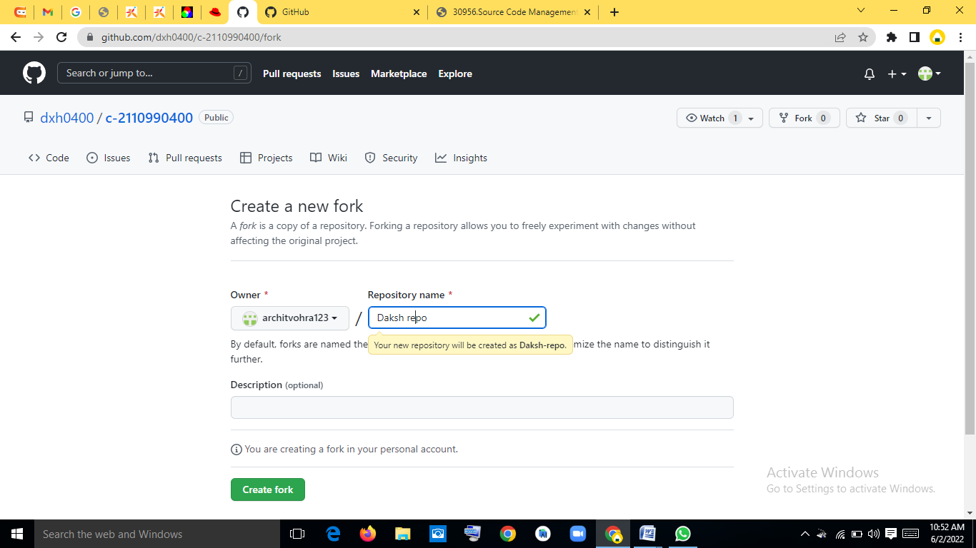

Step3: Now the repo is forked.

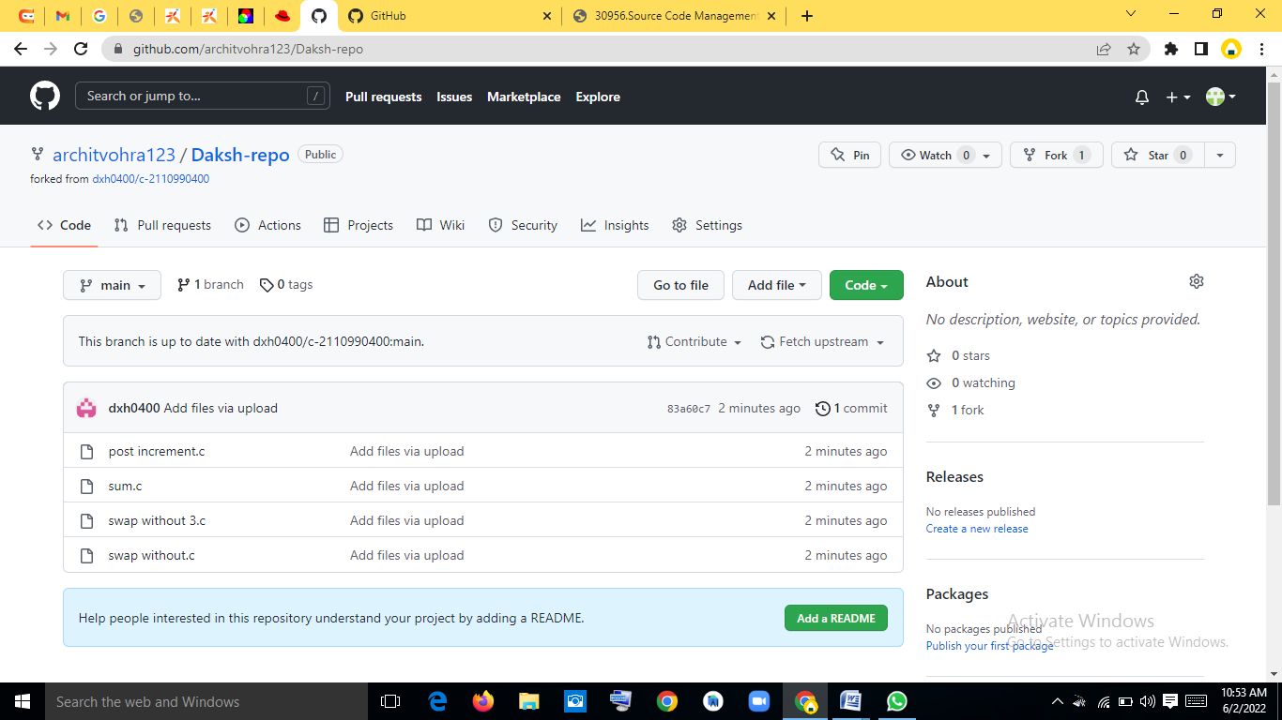

Step4: Now clone that remote repo onto your device.

Step5: Make another branch by using “git checkout –b `branch-name`”



Step6: Now change the code or repo according to you and then commit your changes. Note that everything you are doing upto this point is on the new branch you made at the starting point.

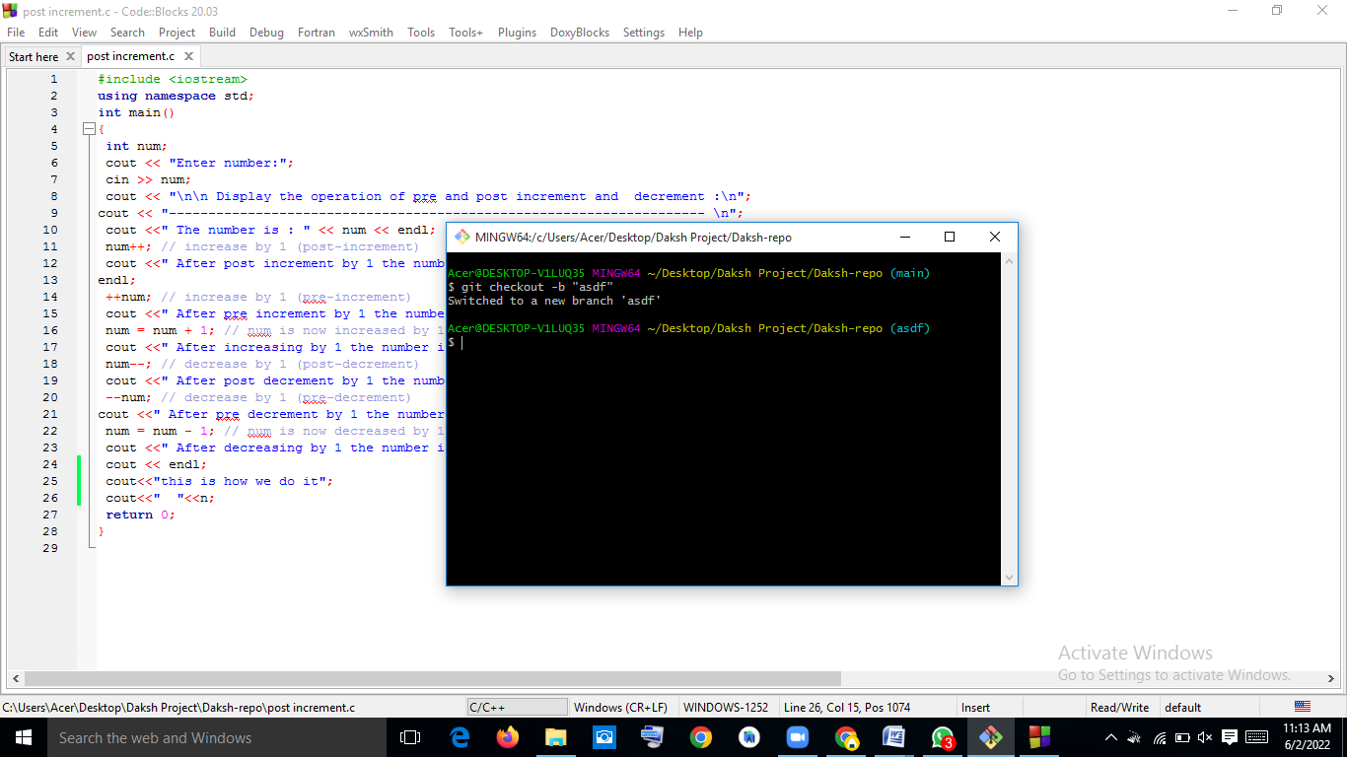

Step7: Now push the repo’s new branch to remote repo by using “git push –u origin `branch-name`”

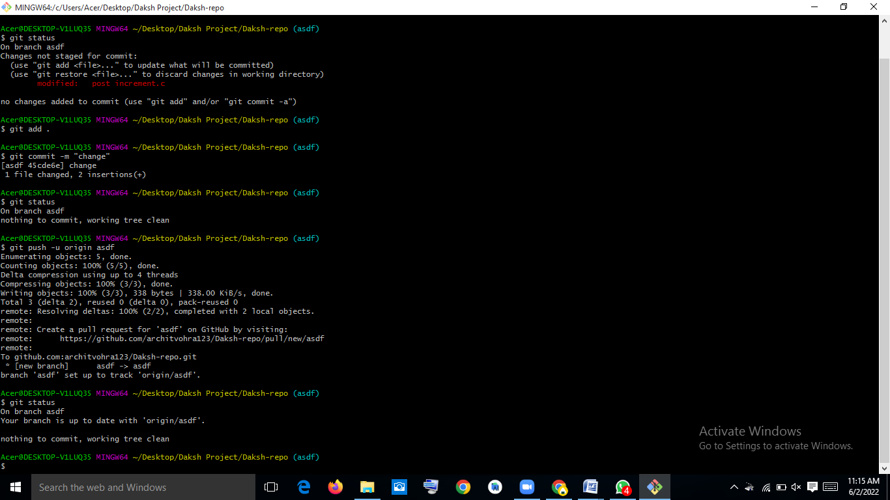

Step8:You will get message like this on your git-hub repo. 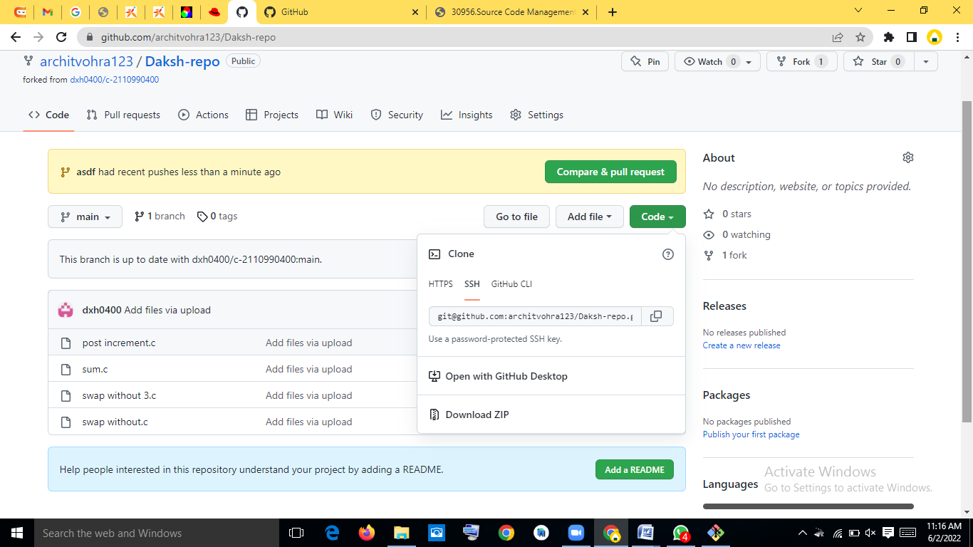

Step-9:Open the pull request, Name it and create the pull request. 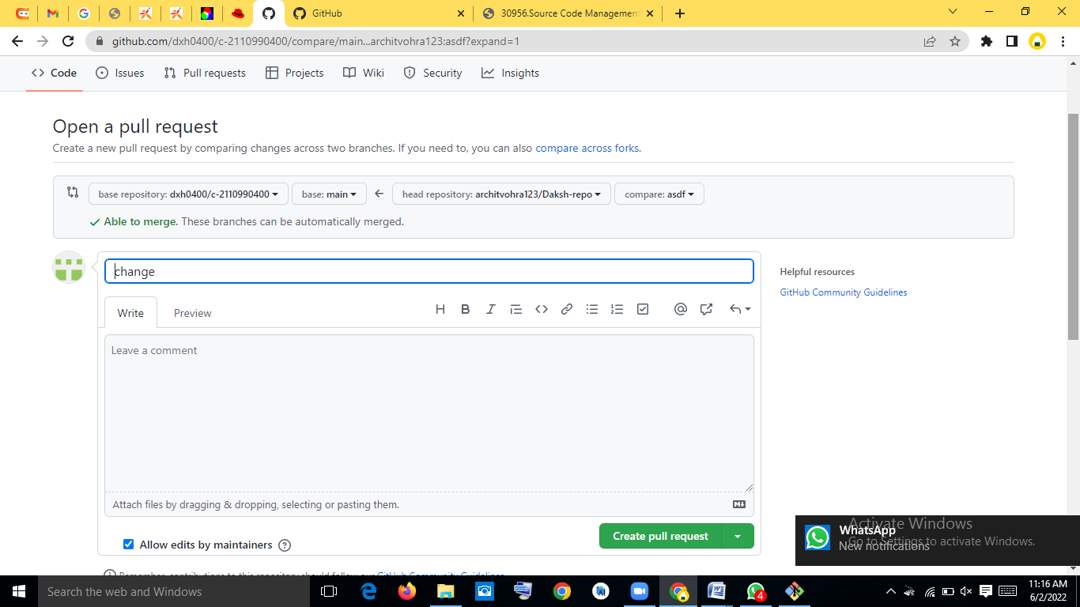 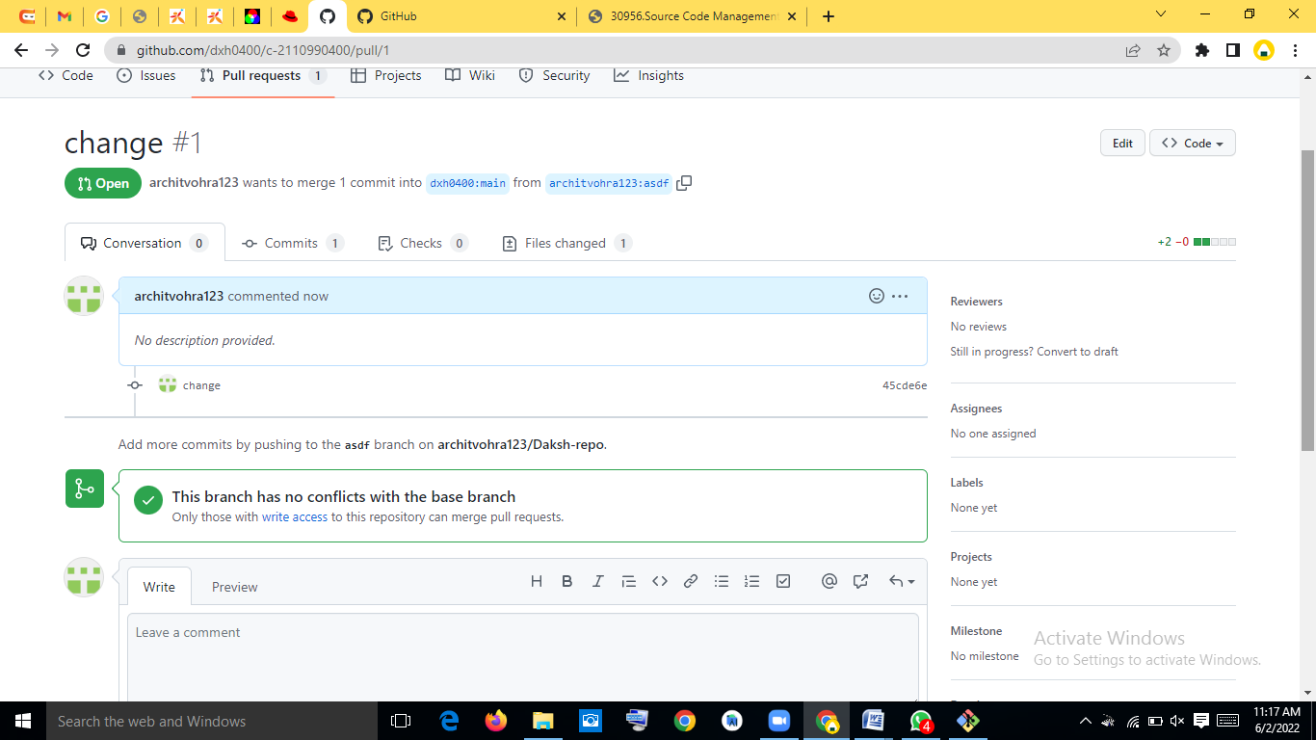

Step 10: Now a pull request will go on to owner’s mail ID regarding the merge.

Forking with Arshdeep:

Step1: Choose the repo to fork.

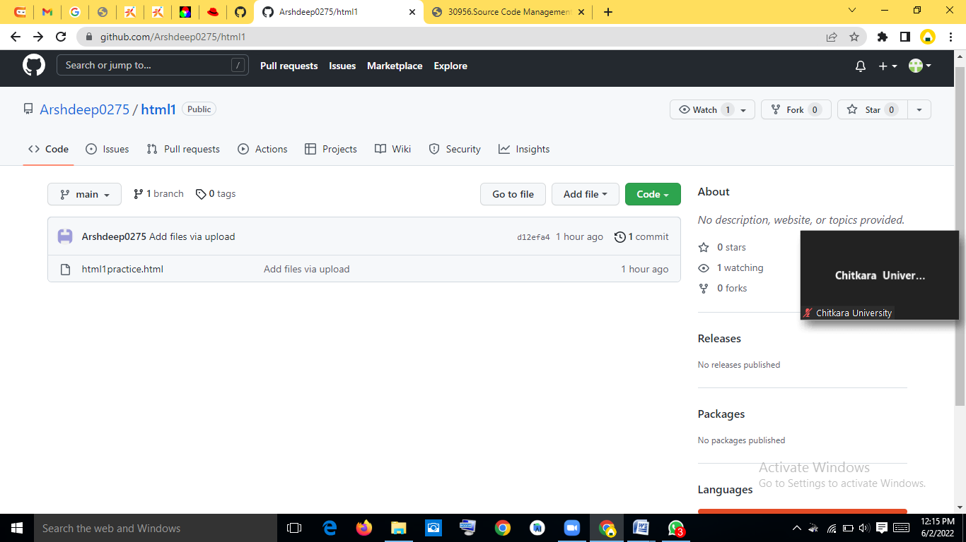

Step 2: Forking that repo by making a new repo in your own github account.

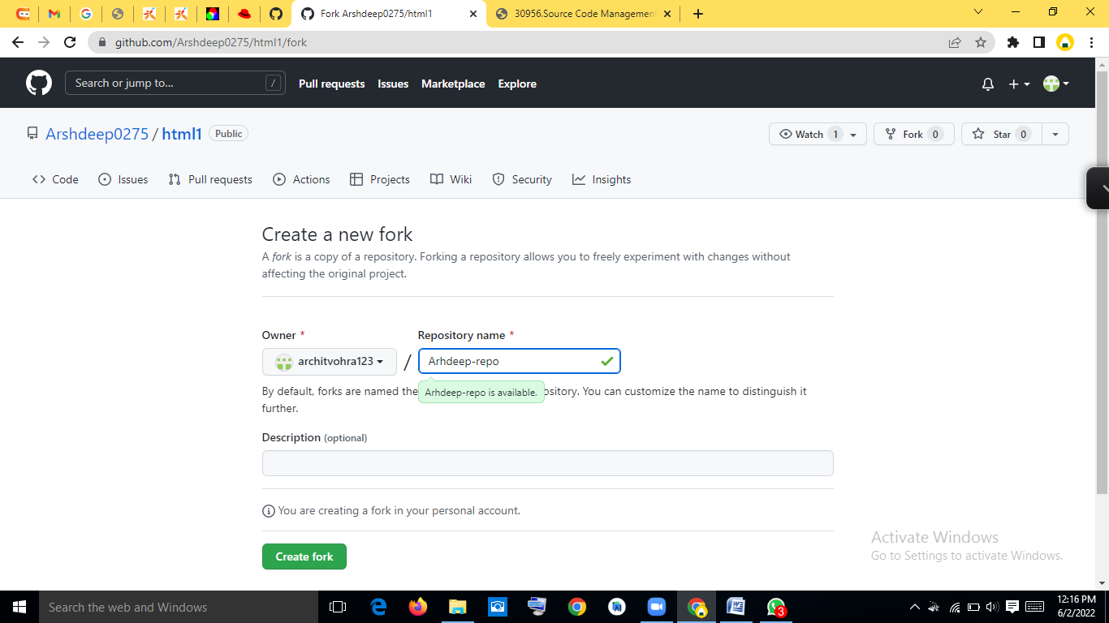

Step3: Now the repo is forked.

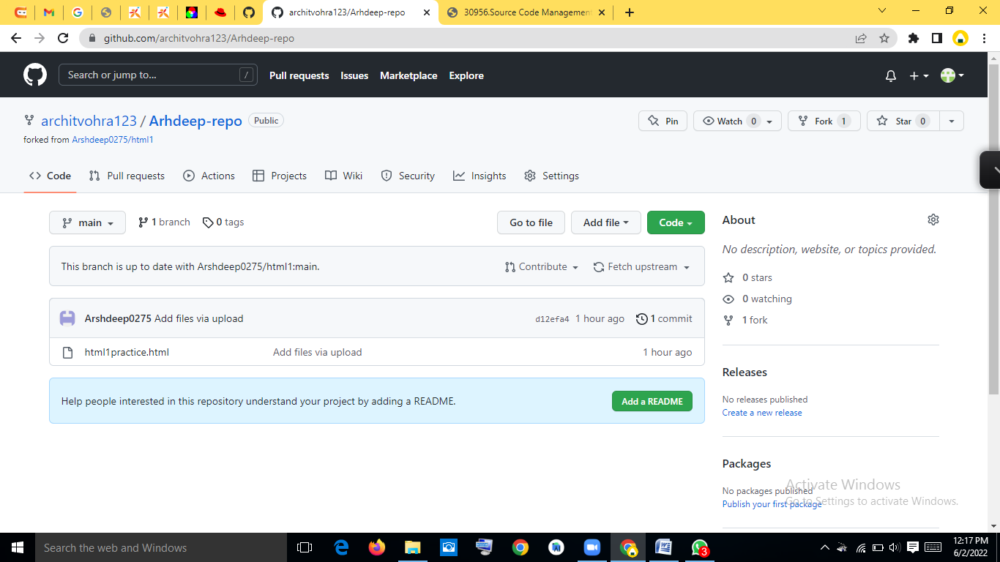

Step4: Now clone that remote repo onto your device.

Step5: Make another branch by using “git checkout –b `branch-name`”



Step6: Now change the code or repo according to you and then commit your changes. Note that everything you are doing upto this point is on the new branch you made at the starting point.



Step7: Now push the repo’s new branch to remote repo by using “git push –u origin `branch-name`”



Step8:You will get message like this on your git-hub repo. 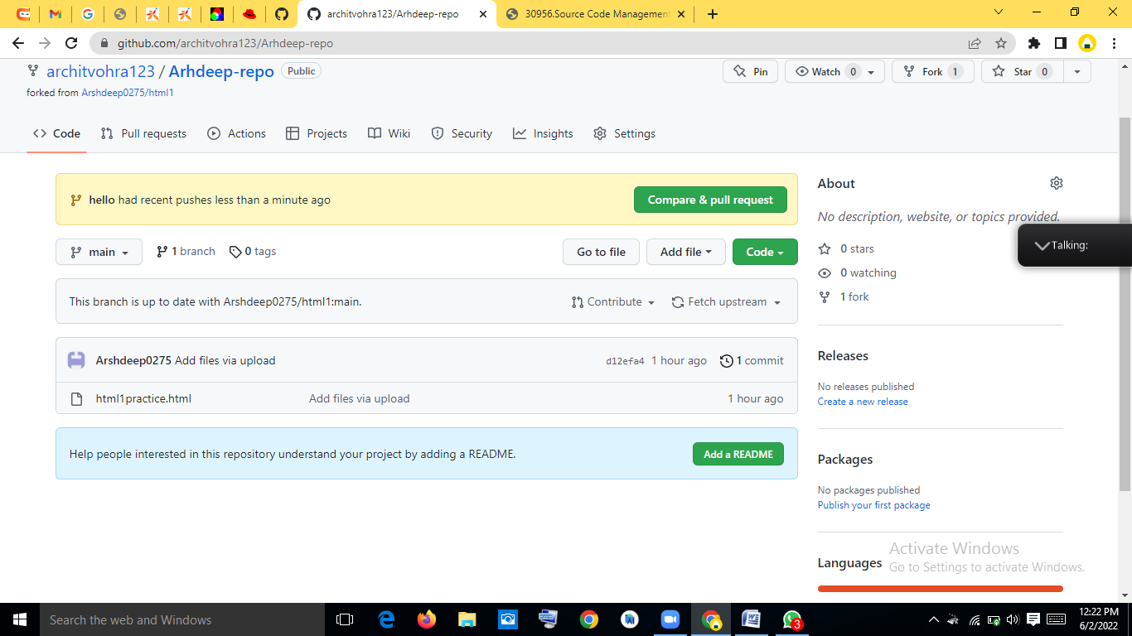

Step-9:Open the pull request, Name it and create the pull request. 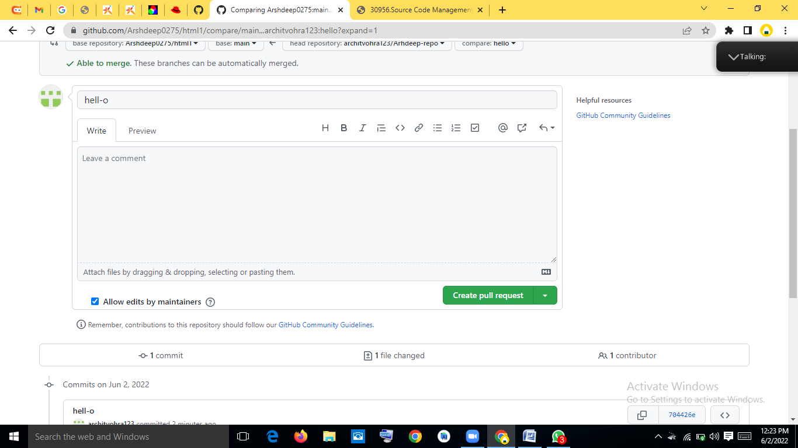 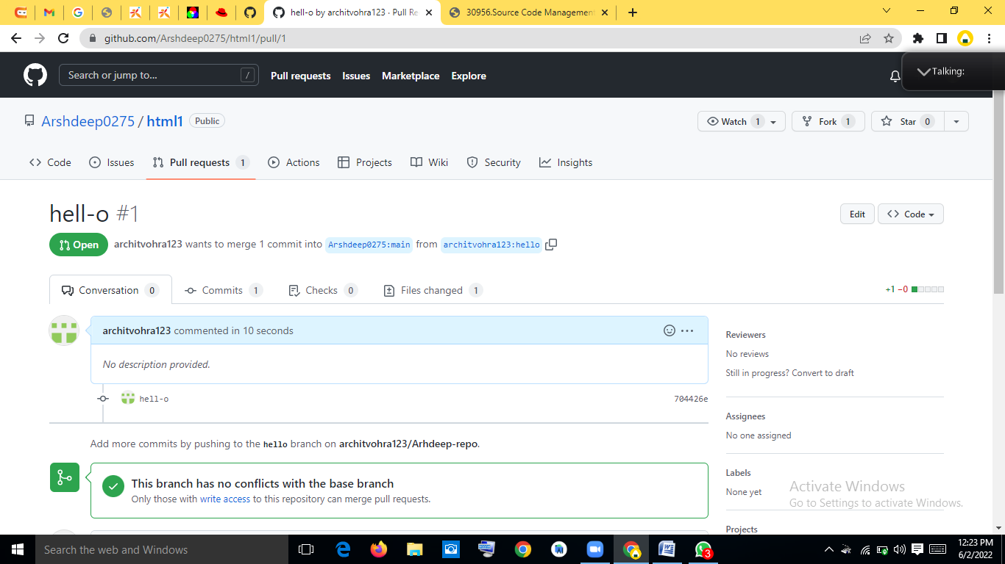

Step 10: Now a pull request will go on to owner’s mail ID regarding the pull request. The owner now accepts it and it automatically merges with the original remote repo.

6. Reference

Reference for few code snips of CSS and HTML were taken from Coding Ninjas video lectures and from few crash courses available on YouTube.

Reference for few code snippets of JavaScript were taken from the Udemy Courses available online.

**Links used for reference**

* <https://www.coursera.org/learn/introduction-git-github>
* <https://www.freecodecamp.org/news/git-and-github-crash-course/>
* <https://www.udemy.com/course/github-ultimate/>
* <https://www.udemy.com/course/git-started-with-github/?LSNPUBID=JVFxdTr9V80&ranEAID=JVFxdTr9V80&ranMID=39197&ranSiteID=JVFxdTr9V80-GmotHk.p_rwC77qokoBs_w&utm_medium=udemyads&utm_source=aff-campaign>